CITY OF BRADFORD METROPOLITAN DISTRICT COUNCIL
JOB PROFILE

DEPARTMENT: Place | SERVICE GROUP: Waste, Fleet, Enviromental Health and Licensing
POST TITLE:  Area Operations Supervisor (City of Culture) | REPORTS TO:  Area Operations Manager (City of Culture)
GRADE: Band 7 |  | SAP POSITION NUMBER :

The following information is furnished to help Council staff and those people considering joining the City of Bradford Metropolitan District Council to understand and appreciate the general work content of their post and the role they are to play in the organisation. The duties and responsibilities highlighted in this Job Profile are indicative and may vary over time. Post holders are expected to undertake other duties and responsibilities relevant to the nature, level and scope of the post and the grade has been established on this basis.
For posts where employees speak directly to members of the Public the post holder is required to demonstrate their ability to speak fluently in English.

As a candidate you will be expected to demonstrate your ability to meet the special knowledge, experience and qualifications required for the role by providing evidence in the application form for the purpose of shortlisting. Applicants with disabilities are only required to meet the essential special knowledge requirements shown by a cross in the end column of this section.

The employee competencies are the minimum standard of behaviour expected by the Council of all its employees and the management competencies outlined are those relevant for a post operating at this level within our organisation.

Both sets of competencies will be used at interview stage and will not be used for short listing purposes.

Key Purpose of Post:
- To assist the Area Operations Manager by supervising and managing a team of up to 15 Street Cleansing Ambassadors and a Mechanical Sweeper Driver, as well working in a team with Gardeners, Neighbourhood Wardens, Environmental Enforcement Officers, PSPO Officers and other staff - responsible for delivering high quality and consistent cleansing across the district.

- To assist in delivering an efficient cleansing service across the Bradford District,.ensuring all staff and vehicles are compliant with all relevant legislation, policies and practices in relation to this specialist area of work including:
- The supervision, motivation and development of the staff involved and .
- The efficient and effective deployment and control of vehicles and other equipment and materials.

- To assist in the provision of a service to support the delivery of City Of Culture events over a 14 months’ programme to maintain a high level of cleanliness and enforcement of environmental issues.

Main Responsibilities of Post:
- Assist in the training and management of staff, workloads and resources including co-ordinating daily work patterns and operations and allocating work and resources. Develop and continually review prescriptive working patterns and new routes and joined up working. Support the Area Operations Manager with basic HR tasks such as return to work interviews. Responsible for the supervision and direction of a small team of employees generally operating in line with defined operational methods, but requiring regular “on the spot” decisions with regard to work schedules, priorities and issues in order to ensure delivery of a quality service.

- To lead and co-ordinate work with multiple small teams working outdoors carrying out street cleansing and environmental maintenance activities within an identified area across the district. This includes delivery of work as directed to support events for the City of Culture.

- Ensure that staff are encouraged to report health and safety issues and that staff operate in accordance with policies and procedures.

- Deliver training on operational issues such as health and safety, customer care and procedures.

- Responsible for driving and operating a wide range of vehicles and plant including vehicles up to 32 tonnes and/or with trailer attachments for transporting mowers, as well as ride-on mowers and pedestrian operated machinery. The post may involve driving refuse collection vehicles from 7.5 tonnes up to 32 tonnes and/or caged tippers from 3.5 tonnes to 7.5 tonnes and/or road sweepers up to 18 tonnes.

- Assist in creating and implementing deployment plans and routes for all staff and vehicles. Monitor the deployment of operational staff on a real time daily basis to maximise resources and improve performance, reporting through any issues to the Area Operations Manager.

- Undertake price/estimates and provide quotes for internal and external customers.

- Responsible for security of equipment, undertaking daily checks, reporting defects and organising repairs.

- Work closely with the Neighbourhood Wardens, Enviromental Enforcement Officers, Public Space Protection Officers and other relevant partners to adress any enforcement issues arising.

- Ensure fleet vehicles comply with all laws and regulations relating to the safe operation of Council vehicles and keep up-to-date and accurate records, eg accidents, breakdowns and vehicle checks.

- Ensure that all equipment is maintained to a high standard. Responsible for security of equipment, undertaking daily checks, reporting defects and organising repairs.

- Monitoring of staff workloads and performance, carrying out the council’s test and inspect, including driving licence checks making recommendations to the Area Operations Manager.

- To be responsible for the security of the depot and buildings within designated area of responsibility, including opening and closing depot/buildings as necessary.

- Assist the Area Operations Manager in the operation of emergency service as required, particularly with buildings within designated area of responsibility, including 24 hour call out duties and the organisation and delivery of out of hours’ response to emergency situations, including winter maintenance.

- Carry out identified duties in the absence of the Area Operations Manager

Structure:

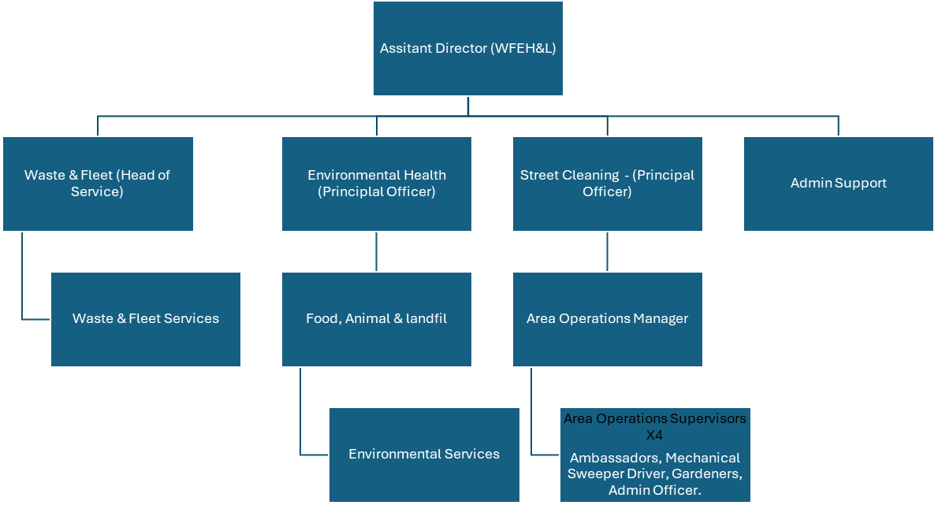

Special Knowledge Requirement. Will be used for shortlisting.
 |  |  | Essential
Applicants with disabilities are only required to meet the essential special knowledge requirements shown by a cross in the end column.
Due to the Governments Fluency in English Duty for posts where employees speak directly to members of the public the postholder is required to meet the Lower threshold level.  You should be able to demonstrate that you can use a wide range of simple words and a standard English sentence structure to express and maintain a flowing conversation even though you pause to think of the correct words with the ability to express and make yourself understood (this will also be tested during the interview). |  |  | X
Able to understand and apply enhanced knowledge of health and safety and environmental operations, policies, procedures and regulations, including risk, across one or more specialist areas. |  |  | X
Uses a range of specialist ICT systems across own work area and or across other areas of work. |  |  | X
Uses, interprets, analyses and communicates information from a variety of sources. |  |  | X
Knowledge of Council services and structure and how they relate to this specialist area of work. |  |  | X
Ability to deliver training in relation to a specialist area of work i.e. health and safety, customer care, operational procedures. |  |  | X
Able to manage successful service delivery, and an ability to build and manage relationships effectively and bring people together to optimise partnership working. |  |  | X
Awareness of and ability to apply approaches that can bring about behaviour change within communities. |  |  | X
Able to carry out vehicle evaluations against established standards. |  |  | X
Relevant experience requirement: Will be used for shortlisting

Demonstrable and recent experience in a similar role which includes the supervision of staff on a daily basis within a large multi-functional organisation.
This should include each of the following: -
- Supervising and motivating staff;
- Deputising for a senior officer;
- Organising daily workloads;
- Applying a knowledge of health & safety, risk assessment and working procedures and
- Dealing with other colleagues and members of the public.

Responsibility for onsite security
Experience of working with a wide range of partners and an understanding of the needs of diverse communities.
Relevant professional qualifications requirement: Will be used for shortlisting

NQF Level 2 or equivalent.
Class C driving licence desired but not essential
Core Employee competencies to be used at the interview stage.
Carries Out Performance Management
Covers the employee’s capacity to manage their workload and carry out a number of specific tasks accurately and to a high standard.
Communicates Effectively
Covers a range of spoken and written communication skills required as a regular feature of the job. It includes exchanging information/building relationships; giving advice and guidance; counselling, negotiating and persuading and handling private, confidential and sensitive information.
Carries Out Effective Decision Making
Covers a range of thinking skills required for taking initiative and independent actions within the scope of the job. It includes planning and organising, self effectiveness and any requirements to quality check work.
Undertakes Structured Problem Solving Activity
Covers a range of analytical skills required for gathering, collating and analysing the facts needed to solve problems. It includes creative and critical thinking; developing practical solutions; applying problem solving strategies and managing interpersonal relationships.
Operates with Dignity and Respect

Covers promoting equality, treating all people fairly and with dignity and respect, maintains impartiality/fairness with all people, is aware of the barriers people face.
Working Conditions:

Must be able to perform all duties and tasks with reasonable adjustment, where appropriate, in accordance with the Equality Act 2010 in relation to Disability Provisions.

Post holders will be expected to work unsocial hours and weekends as part of a 4 x 4 shift rota.

Post may involve driving refuse collection vehicles from 7.5 tonnes up to 32 tonnes and/or caged tippers from 3.5 tonnes to 7.5 tonnes and/or road sweepers up to 18 tonnes.

The nature of the post means that the post holder will come into contact with irate members of the public. Verbal abuse is not uncommon and while physical assault is very rare, there is a potential for this.

Special Conditions:
DBS is required.
Full UK driving licence
Compiled by: CS  Date: 26.07.24 | Grade Assessment Date:  08.08.24 | Post Grade:  Band 7

