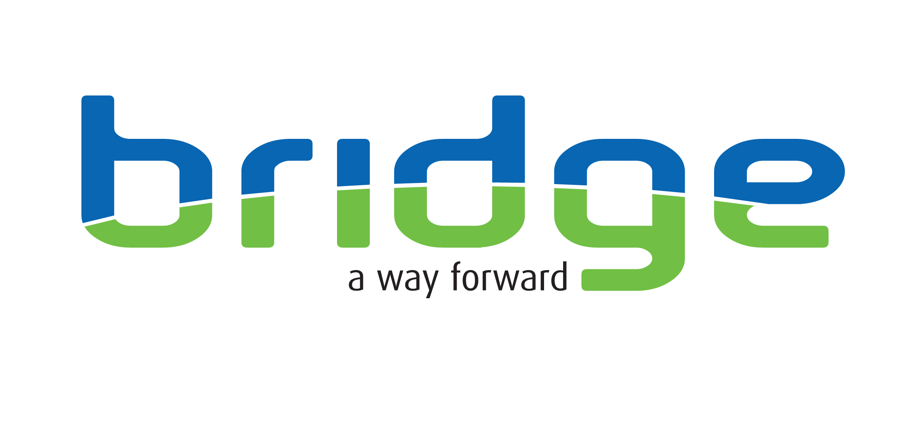
Title of post: Family Navigator

Location: The core base is located at Shipley Owlet Family Hub. The post holder will be expected to travel anywhere in Bradford MBC in the delivery of direct family navigation support services including clients’ homes.

Responsible to: Service Manager

Salary Scale: £29,760 per annum

Hours of Work: 37.5 hours, Core hours Monday to Friday 9 -5pm
Note: The post holder is expected to flexibly deliver the service to meet the needs of the client, this may require adjusting hours on the day to ensure support to appointments or other activities/ interventions/ attending meetings that fall outside of these core hours.

Service Overview
Working closely with colleagues within the Children and Families Trust, Bridge delivers our successful Navigation Model with a small cohort of referred families to the team, typically around 10 family cases per navigator at any given time.
The team work with families who are primarily impacted by substance use and who are experiencing simultaneous additional issues linked to unmet needs and deprivation across a range of domains. This may include poor physical health/mental health, family court involvement, domestic abuse, chronic housing issues, exploitation, financial issues, and criminal justice involvement.
The Bridge Navigation model champions a high level of multi-disciplinary interagency cooperation and joint working relationships with families. We deliver an evidence-based, staged delivery model using trauma-informed approaches that offer intensive in-reach within the home. Navigators are skilled at rapidly building trusted relationships and providing practical supports for individuals/ families. Navigators set up, coordinate and ensure delivery of individualised support packages that access services/interventions families need to build strength, resilience, overcome challenges, gain confidence, and acquire the personal and social assets to meet their aspirations that positively impact their lives. There is a clear aim to support individuals to move to full independence of the service.

Main Duties and Responsibilities

- Assertively make face to face contact and proactively engage with individuals/ families referred, such as; meeting at an individual home, friends or family members home or any agreed place

- Build a trusted and supportive relationship, individualising support for change through undertaking a mutually agreed personalised review of the whole families’ strengths and support needs and levels of wider social and community engagement.

- Proactively link and practically support individuals into the agreed appropriate agencies, services and community assets relevant to the families’ expressed strengths and needs and the level of risk e.g. drug and alcohol services, health, domestic abuse services, sexual health, housing, benefits claims, criminal justice services, employment, training and education programmes and any specialist support services as required etc.

- Provide creative, inspiring person-centred solutions to the unmet needs of families who may have histories of finding engagement challenging

- Maintain appropriate case notes and administrative systems linked to the programme, including maintaining programme data performance/ evaluation systems.

- Produce and present high quality, accurate written reports as and when required, this routinely includes reports for multi-agency meetings outlining individual support needs as part of the overall package of care.

- Develop and maintain excellent working relationships with a full range of partner organisations, services and community programmes and assets, this includes setting up and chairing multi-agency meetings.

- Attend project team and safeguarding case review meetings, applying risk analysis skills and contributing to the exchange of relevant information, problem solving to make positive appropriate, safe case direction decisions

- Apply reflective practice skills to evaluate work carried out
- Contribute to training needs of other workers in this field
- Participate in personal and professional development, updating knowledge as appropriate.
- Fully participate in Bridge’s supervision and support structures.
- To recognise ones, own personal and professional limitations and boundaries and discuss these at supervision and related support meetings.

- To undertake any additional duties, as directed by management which are commensurate with this post.

Job title: Person Specification MARAC Navigator
Attributes | Essential criteria | Desirable criteria | How Identified
Qualifications | Qualified to Social Care Level 3 or qualified through appropriate work and life experience. |  | Application Form  Interview  Certificates
Experience | - Within the last 4 years at least two years’ experience of successfully delivering support services to people experiencing multiple needs/ multiple disadvantage  - Experience of working with and/or managing high-risk cases therapeutically  - Experience of conducting person centred and strengths-based assessments of need and creating mutually agreeing action plans/ risk management plans  - Experience of working co-operatively within a partnership working environment/ model  - Experience of effectively managing risks associated with personal safety | - Experience of working with individuals with substance use issues/ victims or perpetrators of domestic violence | Application Form  Interview  Certificates
Knowledge and skills | - Demonstrable skills in effective engagement, and maintaining inspiring supportive relationships with individuals  - Demonstrates the skills of personal resiliency, being tenacious and a strong ability to deal with difficult situations calmly, tactfully, responsibly and safely  - Demonstrates an understanding of the needs of chronically excluded and vulnerable people  - Applied knowledge of legislation in relation to safeguarding vulnerable groups, including children  - Adaptability in working patterns and style to provide a flexible approach in order to develop and deliver services which are accessible and responsive to the needs of clients  - Skilled cooperative communicator, with evidence of communicating clearly, concisely effectively (both orally and in writing) with individuals, groups, organisations and the public  - Evidence of having worked independently and under pressure, prioritising planning and managing own workload on a day-to-day basis, using effective time management skills  - Skilled at preparing reports and letters and maintaining a care record to a high professional standard and using IT systems – email, word, and entering accurate data into IT data bases/ spreadsheets  - Demonstrate motivation, reliability, commitment to clients, team and interagency working | - Demonstrate skills in the use of motivational interviewing techniques  - Understanding of Trauma Informed Care approaches | Application form  Interview
GENERAL | - Willingness to keep abreast of relevant professional developments and to undertake training for the post.  - The post-holder must adhere to Bridge Policies/Guidelines in force within the organisation  - A dynamic experienced practitioner  - Willingness to work within a performance managed environment and contribute to performance reporting  - Willingness to contribute to the training and development of others, undertake regular supervision and appraisal in line with Bridge policies and actively participate in own professional/personal development and have clear resiliency strategies  - Willing to travel in order to fulfil the requirements of the post.  - Conform to standards of dress, which reflects a professional service.  - This post requires a full driving license and use of a vehicle that is used to transport people engaged with the service to their appointments. |  | Application Form  Interview

Key Behaviours | Works Proactively  Demonstrates initiative, thinks ahead, and takes prompt action to solve problems; completes tasks, overcomes obstacles and seize opportunities.
Key Behaviours | Leads Change & Improves Performance  Responds quickly and positively to change, seeking to continuously improve performance by learning quickly from our mistakes, celebrating our successes, and constantly developing our people and processes.
Key Behaviours | Demonstrates Creativity & Innovation  Applies creative and lateral thinking to organisational issues; challenges the status quo and introduces new ideas, methods and processes.
Key Behaviours | Client & Customer Focused  Focuses on and understand the needs of internal and external service users, members and other stakeholders and strives to deliver a prompt, effective and personalised service. (For ‘service users’, please also read members, stakeholders, and audiences).
Key Behaviours | Influences Others & Communicates Effectively  Positively influences others and where appropriate persuades them to change their views, intentions or actions. Listens closely and communicates clearly both verbally and in writing.
Key Behaviours | Applies & Shares Expert Knowledge  Demonstrates the specialist knowledge and technical requirements of the job. Applies skills and experience to perform the job effectively, completes work to a high standard and shares knowledge across the organisation.
Key Behaviours | Works Collaboratively with Others  Works collaboratively with others for the good of the business; builds a network of good relationships and develops a thorough understanding of the organisation and the wider sector.
Key Behaviours | Values & Respects Others  Respects other individuals; listens and takes into account different opinions, feelings and motivations; is trustworthy and acts with integrity; responds and acts constructively towards others.

