CITY OF BRADFORD METROPOLITAN DISTRICT COUNCIL
JOB PROFILE

DEPARTMENT OF PLACE  Fleet & Transport Services | SERVICE GROUP:  Fleet Workshop
POST TITLE:  Driver/Labourer | REPORTS TO:  Workshop Manager
GRADE: BAND 6 SCP 7-11 | POST REFERENCE (SAP) /  VACANCY CONTROL NUMBER :

The following information is furnished to help Council staff and those people considering joining the City of Bradford Metropolitan District Council to understand and appreciate the general work content of their post and the role they are to play in the organisation. The duties and responsibilities highlighted in this Job Profile are indicative and may vary over time. Post holders are expected to undertake other duties and responsibilities relevant to the nature, level and scope of the post and the grade has been established on this basis.

As a candidate you will be expected to demonstrate your ability to meet the special knowledge, experience and qualifications required for the role by providing evidence in the application form for the purpose of shortlisting. Applicants with disabilities are only required to meet the essential special knowledge requirements shown by a cross in the end column of this section.

The employee competencies are the minimum standard of behaviour expected by the Council of all its employees and the management competencies outlined are those relevant for a post operating at this level within our organisation.

Both sets of competencies will be used at interview stage and will not be used for short listing purposes. Please see the separate guidance information on how to complete the form located on Bradnet.

Key Purpose of Post
To undertake all associated driver and labourer duties and responsibilities to assist with
the efficient running of the workshop area.

Main Responsibilities of Post
- Undertake all duties in compliance with relevant health & safety regulations and work safely in accordance with established safe working procedures.
- Must have due regard for the safety of other employees, members of public and the customer in the delivery of the service
- Be responsible for the use and safekeeping of all workshop tools, equipment, work wear, workstation and associated facilities
- Maintain cleanliness of the working environment and ensure agreed procedures are followed in the workplace
- Must be constantly alert to the proper use of vehicles, plant and equipment to ensure that all safety aspects are adhered to. Responsible for the identification of materials and equipment needed for the required tasks and the completion of all associated paperwork.
- Lead by good example and support managers and colleagues where appropriate
- Must be constantly alert to the proper use of vehicles, plant and equipment and ensure compliance with all safety related aspects

SUMMARY OF MAIN TASKS:

- Carry out general workshop duties including cleaning workshops and depot.
- Transporting vehicles to various sites including to sub- contractors as required.
- Provide general assistance to workshop employees.
- Ensure cleansing of bins within workshops and externally within the depot compound.
- Travelling for and collection of vehicle maintenance parts.
- Steam cleaning vehicles as required.
- Carry out recovery duties as necessary.
- Operate vehicle wash and keep area clean.
- Deal with fuel deliveries.
- To undertake such duties and responsibilities of an equivalent nature/level as may be determined by the Workshop Manager in view of the developing nature of the service
- To undertake any other relevant and related duties as may be required for the smooth running of the Service
- Carry out reasonable instruction from management or supervisors/team leaders
- Order spares at stores
- Maintain a clean and tidy work area
- Liaise with Vehicle Workshop Team Leader(s) and Management where necessary
- Undertake all tasks with due diligence to the best of your ability and be accountable for your repairs
- Undertake other reasonable duties (with competence and experience) as requested in accordance with the changing needs of the organisation
- In pursuit of the Departments commitment to quality, carry out duties in accordance with the stated or implied requirements of the Quality Systems
- The Department is an Equal Opportunities employer and as such Employees are required to comply with good Equal Opportunities practice in every aspect of their work and any other recent requirement
- To be accountable for those appropriate responsibilities as set down in the department’s Safety Policies and in addition to take reasonable care for own health and safety and that of others who may be affected by the work.

Structure:
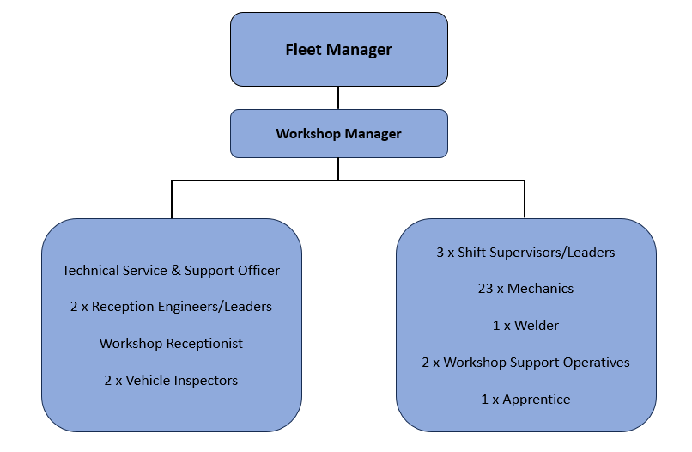

Special Knowledge Requirement (used for short listing). Applicants with disabilities are only required to meet the essential special knowledge requirements, highlighted below)
Due to the Governments Fluency in English Duty for posts where employees speak directly to members of the public, the post holder is required to meet either the Lower threshold level  – where the person is able to demonstrate that they can during the interview:  a) Use a wide range of simple words and a standard English sentence structure to express much of what they want to.  b) Maintain a conversational flow even though they pause to think of the correct words or sentence structure in order to express themselves.  Or the Advanced threshold level  – where the person is able to demonstrate that they can during the interview:  a) Can express themselves fluently and spontaneously, almost effortlessly  b) Only the requirement to explain difficult concepts simply hinders a natural smooth  flow of language | X
 | X  X  X  X  X  X  X  X
  Must be able to drive and have knowledge of the Bradford area and road network
  Must be able to manage time and work schedule within strict deadlines whilst working
  effectively
  Must be able to deal with internal and external customers both face to face and over
  The telephone on a daily basis
  Must be able to work flexibly to accommodate the needs of the service as and when
  required
  Must act with courtesy and professionalism at all times
  Must be able to develop and maintain effective working relationships
  Must contribute to the maintenance of a healthy and safe working environment
  Must be able to adopt a process of continual improvement and suggest ways of
  working more efficiently and effectively to improve service delivery
Relevant Experience Requirement (used in short listing)
- Must have at least 12 months’ experience driving LGV class C+E

Relevant Professional Qualification Requirement (used in short listing)
- Must have a current LGV Class C Licence
- Physically demanding effort required on specific walking, kneeling, bending, pulling, pushing, lifting and carrying or any other physical attribute required
- Must be legally entitled to work in the UK
- GCSE standard literacy and numeracy level.

Core Employee competencies to be used at the interview stage.

Carries Out Performance Management
Covers the employee’s capacity to manage their workload and carry out a number of specific tasks accurately and to a high standard.
Communicates Effectively
Covers a range of spoken and written communication skills required as a regular feature of the job. It includes exchanging information/building relationships; giving advice and guidance; counselling, negotiating and persuading and handling private, confidential and sensitive information.
Carries Out Effective Decision Making
Covers a range of thinking skills required for taking initiative and independent actions within the scope of the job. It includes planning and organising, self effectiveness and any requirements to quality check work.
Undertakes Structured Problem-Solving Activity
Covers a range of analytical skills required for gathering, collating and analysing the facts needed to solve problems. It includes creative and critical thinking; developing practical solutions; applying problem solving strategies and managing interpersonal relationships.
Operates with Dignity and Respect

Covers promoting equality, treating all people fairly and with dignity and respect, maintains impartiality/fairness with all people, is aware of the barriers people face.

Working Conditions:
- Physically demanding effort required on specific walking, kneeling, bending, pulling, pushing, lifting and carrying or any other physical attribute required

- Must be able to perform all duties and tasks with reasonable adjustment, where appropriate, in accordance with the Equality Act 2010 in relation to Disability Provisions

- Must be legally entitled to work in the UK.

Compiled by: SW/PD 26/07/2013  Reformatted by EW 19/08/2025 | Grade Assessment Date: | Post Grade: Fixed

