CITY OF BRADFORD METROPOLITAN DISTRICT COUNCIL
JOB PROFILE

JEGS Reference 00159
DEPARTMENT: | SERVICE GROUP:
POST TITLE: Team Leader Customer & Business Support | REPORTS TO: Customer & Business Support Manager
GRADE: SO2 |  | SAP POSITION NUMBER :

The following information is furnished to help Council staff and those people considering joining the City of Bradford Metropolitan District Council to understand and appreciate the general work content of their post and the role they are to play in the organisation. The duties and responsibilities highlighted in this Job Profile are indicative and may vary over time. Post holders are expected to undertake other duties and responsibilities relevant to the nature, level and scope of the post and the grade has been established on this basis. For posts where employees speak directly to members of the Public the post holder is required to demonstrate their ability to speak fluently in English.

As a candidate you will be expected to demonstrate your ability to meet the special knowledge, experience and qualifications required for the role by providing evidence in the application form for the purpose of shortlisting. Applicants with disabilities are only required to meet the essential special knowledge requirements shown by a cross in the end column of this section.

The employee competencies are the minimum standard of behaviour expected by the Council of all its employees and the management competencies outlined are those relevant for a post operating at this level within our organisation.

Both sets of competencies will be used at interview stage and will not be used for short listing purposes.

Key Purpose of Post:
- Lead and develop teams to ensure provision of the best practicable level of customer service, communication and overall business support including financial, procurement and recruitment to the Hackney Carriage & Private Hire Service.

- To ensure proper determination of complaints about service provision and similar. Engage with members of the hackney carriage and private hire licensed trade, customer groups and similar interested parties to seek their views on service provision though a variety of means including face to face meetings, newsletters/social media etc. (as appropriate)

- To take operational supervision of the relevant customer and business support area, ensuring that resources are used effectively to address priority issues. Set, report against and achieve performance and quality standards and targets and outcomes on an individual and service basis to optimise service delivery. This will include taking appropriate action where delivery falls below target.

Main Responsibilities of Post:
- Lead motivate and develop staff with the aim of achieving high quality, customer focused licensing service with effective professional business support.

- Lead on the delivery of internal and external communications, surveys, bulletins newsletters, events and drop in sessions.

- Ensure that all incoming and outgoing communications and correspondence including complaint handling which should be managed in line with the Councils Corporate Complaints Procedure and within Council processing timeframes. Communications should be appropriate, helpful, respectful and clear using plain English. Update information on social media and the Council’s website.

- To work in partnership with a variety of agencies and representative groups,
internal and external to the Council, for the purpose of developing and implementing policies and associated services.

- Ensure that all activities of the team are carried out in accordance with a wide range of legal requirements including Equalities and Human rights legislation. To prepare accurate information in response to freedom of information and similar requests and help determine when exemptions from releasing information should apply. To ensure security of data and information in compliance with the Council’s Information Security policy, Data Protection legislation and GDPR 2018.

- Manage staff including undertaking supervision and appraisals, training and developing staff, dealing with attendance and performance issues, including presenting at hearings, and responsibility for recruitment and selection.

- To lead and support the Customer and Business Support Manager in the administration and monitoring of budgets and participate in budget discussions, making recommendations as required.

- Plan and organise general meetings, public meetings and events as required and provide any support required for participants.

- Organise notetaking for meetings, management investigations, disciplinary and capability hearings as required.

- Manage the ordering and maintenance of stock levels of stationery, material and publications as required and in accordance with procurement.

- Lead in all financial transactions on SAP. Train and supervise staff on the use of preferred suppliers and procurement guidance within the Council. Maintain all records in accordance with Key Controls and to provide an annual submission for audit purposes.

- Responsible for the supervision of staff individual work programmes which ensure that all statutory deadlines, procedures and other performance measures including those relating to customer satisfaction, customer service levels, service KPI’s and the wider aims of the business support teams are, taking appropriate action where delivery falls below target.

- Contribute positively to the Service and general development of the Service.

- To undertake projects, produce periodic reports and carry out other duties commensurate with the role as required.

- To deputise for other Licensing Service managers in all areas of management supervision and administration in their absence.

Structure:
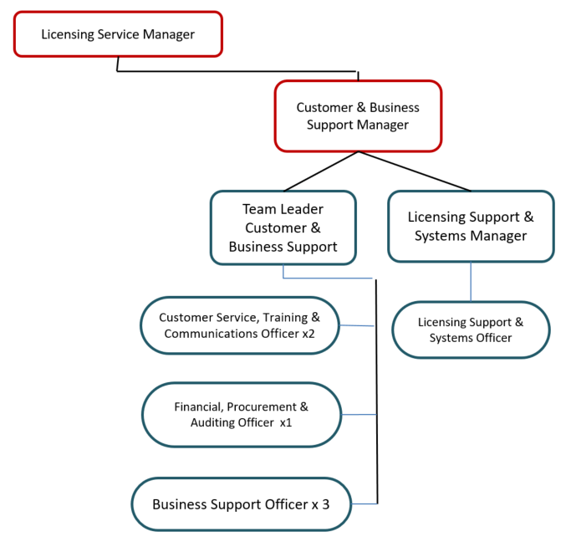

Special Knowledge Requirement: Essential for shortlisting.
Applicants with disabilities are only required to meet the essential special knowledge requirements shown by a cross in the end column
 | Essential
Due to the Government’s Fluency in English for posts where employees speak directly to members of the public the post holder is required to meet the Advanced threshold level which will be applied where the post holder requires a greater level of sensitive interaction with the public.  You must be able to demonstrate that you can express yourself fluently and spontaneously (this will also be tested during the interview). | X
Carries out the working practices, procedures and basic operations across a specialist area or number of specialist areas …………….. | X
Uses knowledge, safety and environmental policies , procedures and regulations, including risk in own area and/or other areas of work (inc legislation) | X
Uses a range of specialist ICT systems across own work area and or across other areas of work. | X
Oversees or contributes to the management of a budget , keeping costs within agreed levels for own section/team | X
Uses, interprets, analyses, communicates complex numerical information. | X
Is extremely organised and able to complete work to the highest standard of quality, accuracy and attention to detail. | X
Able to carry out audit processes to ensure the Licensing Service meets the highest standard of quality assurance and customer expectations. | X
Able to interpret and present complex data gathered in a meaningful format. | X
Able to interpret and present complex data gathered in a meaningful format. | X
Able to diffuse difficult, challenging and potentially harmful situations, support colleagues in dealing with difficult situations, intervene as necessary and resolve situations. | X

Relevant experience requirement: Essential for shortlisting

The applicant is required to provide evidence of having previously spoken fluently to members of the public in order to meet the Advanced threshold level outlined under Special Knowledge above.
Experience of managing staff in a very busy customer service environment, dealing with a high volume of customers and the general public in person and on the telephone, sometimes in difficult and confrontational situations.
Must be able to demonstrate a high standard of numeracy and literacy.
Experience and ability to use ICT systems and applications is essential.
Relevant professional qualifications requirement: Essential for shortlisting

QCF Level 4, NVQ Level 4 in Customer Services (or equivalent in a similar subject), or 5 years relevant demonstrable experience.

Core Employee competencies at manager level to be used at the interview stage.

Carries Out Performance Management – covers the employee’s capacity to manage
their workload and carry out a number of specific tasks accurately to a high standard.
Communicates Effectively - covers a range of spoken and written communication skills required as a regular feature of the job. It includes exchanging information/building relationships, giving advice and guidance, counselling, negotiating and persuading and handling private, confidential and sensitive information.
Carries Out Effective Decision Making - covers a range of thinking skills required for taking initiative and independent actions within the scope of the job. It includes planning and organising, self effectiveness and any requirements to quality check work.
Undertakes Structured Problem Solving Activity - covers a range of analytical skills required for gathering, collating and analysing the facts needed to solve problems. It includes creative and critical thinking, developing practical solutions, applying problem solving strategies and managing interpersonal relationships.
Operates with Dignity and Respect - covers treating everyone with respect and dignity, maintains impartiality/fairness with all people, is aware of the barriers people face.

Management Competencies: to be used at the interview stage.

Operates with Strategic Awareness Our managers work with corporate priorities and policies in a joined up way with others, internally and externally. Works democratically, transparently and accountably.
Practices Appropriate Leadership Our managers motivate their staff to exceed expectations through raising their awareness of goals and moving them beyond self interest for the sake of the team or service. They consider serving the District in all that they do.
Delivering Successful Performance Our managers monitor performance of services, teams & individuals against targets & celebrate great performance. They promote the District’s vision & work to achieve Council’s values & agreed outcomes.
Applying Project and Programme Management Our manager’s work to ensure that outcomes and objectives are achieved within desired timescales, make best use of resources and take a positive approach to contingency planning.
Developing High Performing People and Teams Our managers coach individuals and teams to achieve their potential and take responsibility for continuous improvement. They champion the Council’s values and goals.
Working Conditions:

Must be able to perform all duties and tasks with reasonable adjustment, where appropriate, in accordance with the Equality Act 2010 in relation to Disability Provisions.
Special Conditions:
Compiled by:C Stos  Date: 2022 | Grade Assessment Date: Nov 2022 | Post Grade: SO2

