CITY OF BRADFORD METROPOLITAN DISTRICT COUNCIL
JOB PROFILE

DEPARTMENT: Legal and Democratic Services | SERVICE GROUP: Education, Employment and Litigation
POST TITLE: Lawyer/Senior Lawyer  (Education/SEN law) | REPORTS TO: Team Leader  (Education, Employment and Litigation)
GRADE: PO 3-6 (via career grade progression criteria) |  | SAP POSITION NUMBER :

The following information is furnished to help Council staff and those people considering joining the City of Bradford Metropolitan District Council to understand and appreciate the general work content of their post and the role they are to play in the organisation. The following points should be noted:

The employee competencies are the minimum standard of behaviour expected by the Council of all its employees and the management competencies outlined are those relevant for a post operating at this level within our organisation.

Both sets of competencies will be used at interview stage and will not be used for short listing purposes. As a candidate/employee you will be expected to demonstrate your ability meet the special knowledge, experience and qualifications required for the role by providing evidence in the application form for the purpose of shortlisting.

Key Purpose of Post:
To assist the Team Leader and the Deputy Team Leader in the provision of high quality professional legal services in the areas of Education Law with a focus on SEN law.
Main Responsibilities of Post:
The postholder is required to exercise professional judgment and make all day-to-day operational decisions on allocated matters and cases in the context of legal advice and representation to the instructing client and provide advice and assistance to Council officers and members.

The post holder is expected to influence and negotiate with contacts both internal and
external to the Council. Contacts include officers at Chief Executive level and below,
elected members, Courts, Tribunals and regulatory bodies of staff, private practice solicitors and barristers and other professionals involved in the area of work of the Education, Employment and Litigation Law Team.

The main duties of the post are:

- To represent the Council in SEND tribunal proceedings including conducting advocacy.

- To provide advice and draft responses in respect of Judicial Review proceedings at the Pre-Action Protocol stage.

- Provide advice on any matters relating to Education Law and SEN Law to the Children’s Services Department; to other Council officers, the Council’s Committees any organisation with which the Council has a formal arrangement for the giving of advice including the Bradford Children and Families Trust.

- To give legal advice and guidance to the Council’s officers and to Committees and Sub-Committees of the Council.

- To provide supervision and support to more junior staff.

- To act under pressure in the face of competing demands arising from emergency and urgent situations.

- To deliver training to colleagues, clients and elected members.

- To ensure that advice provided and cases are conducted to professional standards, in a timely manner and in compliance with relevant legislation, Statutory Guidance and Practice Directions and to ensure that Court/Tribunal deadlines are met.

- To be flexible and undertake such duties as may be allocated by the Team Leader or Deputy Team Leader, to include the preparation of reports, advice and guidance.

- To advise Committees, Sub-Committees, Members, Officers and any organisation with which the Council has a formal arrangement for the giving of advice including the Bradford Children and Families Trust.

- To provide professional legal services to the Council’s Departments, Children’s Services and Adults, Social Care and Health and Place Departments including the Office of the Chief Executive and Corporate Resources.as may be required from time to time.

- To assist other public authorities within the West Yorkshire area on legal matters as may be required from time to time.

Structure

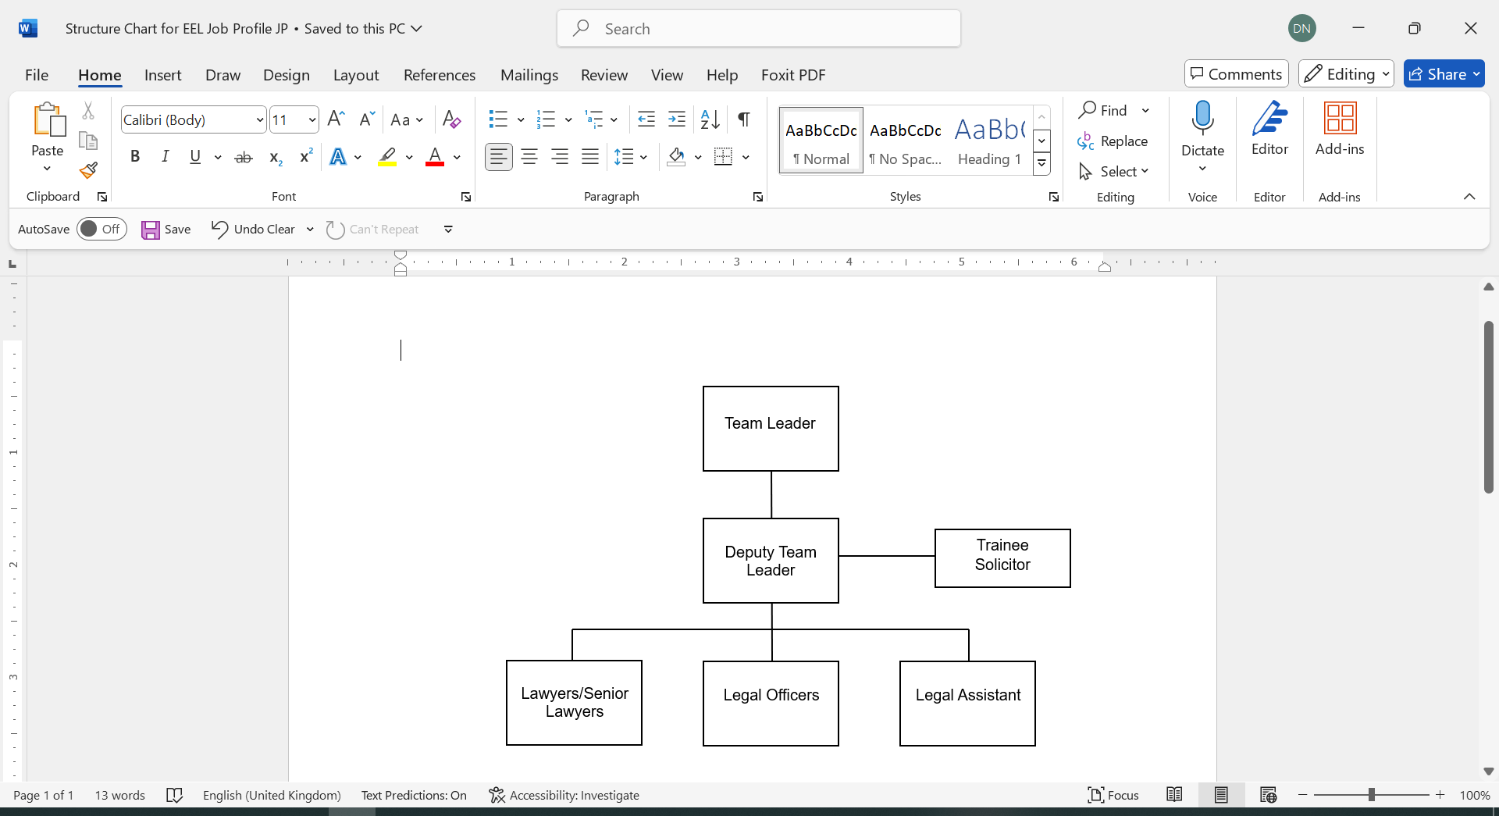

Special Knowledge Requirement:
Applicants with disabilities are only required to meet the essential special knowledge requirements shown by a cross in the end column.
 |  |  | Essential
Due to the Government’s fluency in English Duty for posts where employees speak directly to members of the public the post holder is required to meet the Advanced Threshold level which will be implemented where the post requires a greater level of sensitive interaction with the public, (eg in children’s centres) – where the person is able to demonstrate that they can during the interview’s:  a) can express themselves fluently and spontaneously , almost effortlessly  b) Only the requirement to explain difficult concepts simply hinders a natural smooth flow of language |  |  | x
Carries out the working practices, procedures and operations across the specialist areas of Education, Employment and Litigation. |  |  | x
Understands and applies health and safety working practices, including risk in their own area of work. |  |  | x
Uses a wide range of basic computer applications |  |  | x
Knows and understands how to analyse, interpret and present complex information from a variety of sources |  |  | x
Relevant experience requirement:
Experience as a paralegal, legal officer, trainee solicitor, solicitor, barrister or Fellow of the Chartered Institute of Legal Executives in the area of law relating to education and SEND .
Relevant professional qualifications requirement:
The post holder will be a solicitor entitled to practice in England and hold or anticipate being awarded a practising certificate, a barrister entitled to practice in England and holding a current practising certificate or a Fellow of the Chartered Institute of Legal Executives.
Core Employee Competencies
Carries Out Performance Management
Covers the employee’s capacity to manage their workload and carry out a number of specific tasks accurately and to a high standard.
Communicates Effectively
Covers a range of spoken and written communication skills required as a regular feature of the job. It includes exchanging information/building relationships; giving advice and guidance; counselling, negotiating and persuading and handling private, confidential and sensitive information.
Carries Out Effective Decision Making
Covers a range of thinking skills required for taking initiative and independent actions within the scope of the job. It includes planning and organising, self effectiveness and any requirements to quality check work.

Undertakes Structured Problem Solving Activity
Covers a range of analytical skills required for gathering, collating and analysing the facts needed to solve problems. It includes creative and critical thinking; developing practical solutions; applying problem solving strategies and managing interpersonal relationships.

Operates with Dignity and Respect
Covers promoting equality, treating all people fairly and with dignity and respect, maintains impartiality/fairness with all people, is aware of the barriers people face.

Management Competencies: to be used at the interview stage.
Operates with Strategic Awareness
Practices Appropriate Leadership
Delivering Successful Performance
Applying Project and Programme Management
Developing High Performing People and Teams
Working Conditions:
Must be able to perform all duties and tasks with reasonable adjustment, where appropriate, in accordance with the Equality Act 2010 in relation to disability provisions.

Must be able to work evenings, weekends and Bank Holidays as required by the needs of the service.
Special Conditions:
Management may require that a Disclosure and Barring check or similar be carried out as part of the recruitment process, depending on the areas of work being undertaken.
Compiled by:  Dermot Pearson  Date: 16 March 2015  Amended by LB 22 11 17  Amended by JG 02.12.24 | Grade Assessment Date: | Post Grade:  PO3-PO6
For HR use only | SAP Input Date | Name of Data Inputter

