CITY OF BRADFORD METROPOLITAN DISTRICT COUNCIL
JOB PROFILE

DEPARTMENT: Place | SERVICE GROUP: Planning, Transportation & Highways
POST TITLE: Senior Engineer (Structures) | REPORTS TO: Group Engineer
GRADE: PO2 – PO4 | SAP POSITION NUMBER : 11007507,11007649, 11007513

The following information is furnished to help Council staff and those people considering joining the City of Bradford Metropolitan District Council to understand and appreciate the general work content of their post and the role they are to play in the organisation. The duties and responsibilities highlighted in this Job Profile are indicative and may vary over time. Post holders are expected to undertake other duties and responsibilities relevant to the nature, level and scope of the post and the grade has been established on this basis.
For posts where employees speak directly to members of the Public the post holder is required to demonstrate their ability to speak fluently in English.

As a candidate you will be expected to demonstrate your ability to meet the special knowledge, experience and qualifications required for the role by providing evidence in the application form for the purpose of shortlisting. Applicants with disabilities are only required to meet the essential special knowledge requirements shown by a cross in the end column of this section.

The employee competencies are the minimum standard of behaviour expected by the Council of all its employees and the management competencies outlined are those relevant for a post operating at this level within our organisation.

Both sets of competencies will be used at interview stage and will not be used for short listing purposes.

Key Purpose of Post:
- Carry out feasibility and concept studies, public engagement and consultation, design, inspections, assessments, procurement, construction supervision and project management on a variety of structural and civil engineering projects for programmes undertaken by the service on behalf of internal and external clients.
- To support and advise elected members of Council and MPs as the accountable representatives of the public and other key stakeholders and to support the Principal Engineer in the performance of functions associated with the servicing of Council and other committees, neighbourhood forums and public engagement events.
- Initiate, develop and promote Local Transport Plan and Community Strategy projects on behalf of the Council.
- To provide expertise, technical support to the processes and proceedures and specialist knowledge in aspects of the following appropriate to the placement within the Service:

- Civil and Structural engineering;
- Building Structures

- Be responsible for the supervision and direction of junior members of the team in relation to the delivery of projects and activities of the service including Engineers, Technicians, Inspectors, Clerks of Works and Apprentices.
- Ensure that the Council’s legal obligations as Highway Authority under the Highways Act, Road Traffic Act and other allied legislation are fulfilled.
- Ensure the services delivered meet the needs of local people, that continuous improvement in delivery is actively pursued and that the performance targets are achieved.
Main Responsibilities of Post:
Duties will include most, or all, of those listed below according to degree of experience and training reached and placement within the technical specialism units of the Service.

As a Technical Specialist:

- Provide independent judgement, advice and guidance based on evaluation and analytical skills to produce alternative solutions to a wide range of complex engineering and procurement problems, formulate recommendations and solutions appropriate to technical specialism including, but not limited to, the provision of advice related to improvements secured through legal agreements with third parties.

- Undertake and certify the acceptance of technical checks of engineering information provided by third parties as being in accordance with established standards and Council requirements.

- Carry out investigations, feasibility studies and concept designs of alternative solutions to engineering and procurement problems as required including such schemes as may arise from the Local Transport Plan, revenue budgets and other external funding sources. Prepare feasibility designs, calculations, budget estimates, outline programmes, project briefs, work instructions and commissions for Consultants or other Service units as appropriate in line with established Contract Standing Orders using framework arrangements or specific commissions.

- Oversee and/or carry out the detailed design of civil, structural and highway engineering schemes including schemes for:

  - Highway structures and demolition works;
  - Building Structures

Co-ordinating the resources and requirements of other departments and bodies during the process of design.

- Lead the procurement, award and administration of contracts according to role within the service for:

  - Civil engineering works;
  - Highway Structures, demolition and associated works;
  - Building Structures

and the supervision of construction, including undertaking checks for compliance with safety requirements, conditions of contract, drawings and specification and the issuing of instructions to this end. Prepare and issue orders under various term contracts and/or specific tender documentation to tenderers. Undertake the processing of site measure, negotiation and settlement of claims, resolution of contractual issues, payments and preparation of final accounts and variation orders in accordance with the contract terms and the Council’s Standing Orders and Financial Regulations.

- Act as the Engineer’s Representative or equivalent in contractual matters related to civil engineering works including undertaking the supervision, inspection, monitoring and management of allocated construction projects ensuring compliance with documentation with regard to quality, methods of working etc.
- Undertake checking and evaluation of the following appropriate to role within Service:
  - Consultation documents, questionnaires, exhibition and displays;
  - Diagnostic and survey data;
  - Proposal for highways and other structures;
  - Design briefs, data and preliminary/detailed highway scheme designs.
  - Structural and operational calculations
  - Engineering Drawings, Specifications, Bills of Quantity and Project Estimates.

- Manage and contribute to the leadership of all necessary data acquisition, inspections, surveys and assessments in connection with role and undertake investigations appropriate to area of expertise including where appropriate with other public bodies. Prepare high quality written documents, statistical analysis and correspondence and maintain such manual or computerised records as necessary for the efficient and accountable operation of the Service.

- Be fully aware of the political dimension of a local authority and be responsive to the legitimate interests of local ward members, committees and sub-committees. Establish effective, courteous and responsive lines of communication with Members, thirds parties, the community, the press etc. to keep all clearly informed of priorities, targets and progress. Act as liaison between external parties and other internal units. Maintain manual and computerised records of all correspondence and actions.

- Be competent in the use of appropriate technical computer software necessary for carrying out your duties and recommend appropriate improvements to office systems.

- Prepare and present committee reports for the Constituency Area and other Committees, draft briefs for Members and senior officers. Attend Parish Council, Town Council and Neighbourhood Forum meetings.

- Take a leading role in ensuring compliance with and on-going development of the Service’s Health and Safety Policy and in particular the requirements of the Construction, Design & Management Regulations (CDM) and other safety legislation together with the Quality Management system, preparing and recommending further development as necessary.

- Liaise with other teams and units in the preparation of legal agreements/orders and requirements thereof.

- Take decisions and direct actions in accordance with the current Scheme of Delegation in relation to highway matters appropriate to the role. (28)Co-ordinate, control and maintain all relevant management systems recommending improvements to ensure best use of available resources both financial and personnel.

- Prepare reports and statistical information for use in policy analysis, business plans, service charters, service level agreements, service plans etc. recommending changes to policy and procedures as required.

- Take enforcement action including preparation of and serving of notices. When appropriate prepare evidentiary statements and documentation for court / legal action, and attend in court and public inquiries as expert witness on behalf of the Council. Arrange recovery of costs associated with enforcement activities.

- Attend public exhibitions and other public meetings. Foster good relationships with clients, community groups and affected parties to provide the best possible solution for service needs having taken account of the views of end users or their representatives during the formative stages of projects and analysed user views and feedback after project completion.

- Contribute to the initiation, development and co-ordination of rolling programmes of works and schemes to achieve the Government’s, Council’ and Service’s agreed objectives and targets in relation to highway assets including liaising with other external partners as necessary. Use appropriate computer modelling techniques to develop documentary evidence for programme determination and decisions including but not limited to, deterioration modelling and asset management records.

- Where appropriate be involved in the direction, monitoring and implementation of the Winter and Emergency service arrangements as required. When required to do so in the event of an emergency, assist in the provision of engineering expertise at the scene of an incident, give advice and organise emergency works and long-term solutions with respect of the highway, highway related structures or building and demolition works.

- Assist in the development of the Highway Asset Management Plan and other policies/plans related to the highway maintenance function. Maintain a detailed knowledge of highway assets appropriate to specialism. Contribute to the highway valuation process.

- Proactively manage highway assets to the benefit of all road users maintaining operational integrity on a 24/7 basis through direct intervention or instruction of maintenance contractors as appropriate.

- Investigate, develop and review policies relating to the activities of the Service as may be determined by the Service Manager from time-to-time, in consultation with the post holder.

- Undertake such other duties and responsibilities of an equivalent nature, as may be determined by the Service manager from time-to-time, in consultation with the post holder.

As a Supervisor:

- Advise the Principal Engineer on the planning and managing of service improvements based on a performance management framework and communicate progress to customers and partners.

- Undertake, plan and arrange continuing professional development (CPD) activities on behalf of self and others in areas appropriate to role. Advise the Principal Engineer on the professional development needs of more junior staff. Maintain a detailed up-to-date knowledge of appropriate techniques, statutory instruments, legislation, application of new technology and materials appropriate to role within Service. Understand the requirements of design manuals, codes of practice, technical instructions and memoranda and ensure that such requirements are applied.

- Supervise and check more junior staff on technical and procedural matters based on a sound understanding of core engineering principles and knowledge of the values of the Council thereby supporting the Principal Engineer in ensuring the proper discipline, conduct, training, health and safety and welfare of the staff is maintained. Where required to do so deputise for the Group Engineer/Principal Engineer in his/her absence.

- Represent the Service at meetings internal to the Authority and with external bodies and members of the public at the appropriate level, including where necessary deputising for the Group Engineer/Principal Engineer.

As a Project Manager
- Develop, programme and lead on the delivery engineering solutions and schemes of working with the minimum of guidance. Proactively manage the progress of own workload using extensive project management skills and understanding of project management processes including that of any allocated staff, setting objectives, targets and ensuring effective decision making to deliver successful schemes or projects within defined budget and programme constraints with the minimum of guidance. Project manage external consultants and contractors to ensure delivery of project and services to agreed targets.

Financial:

- Monitor costs against pre-determined budgets and targets initiating minor amendments as necessary and recommending corrective action as appropriate. Ensure that all reports in respect of financial approvals are completed to ensure that projects or programmes are delivered to budget.

Structure:

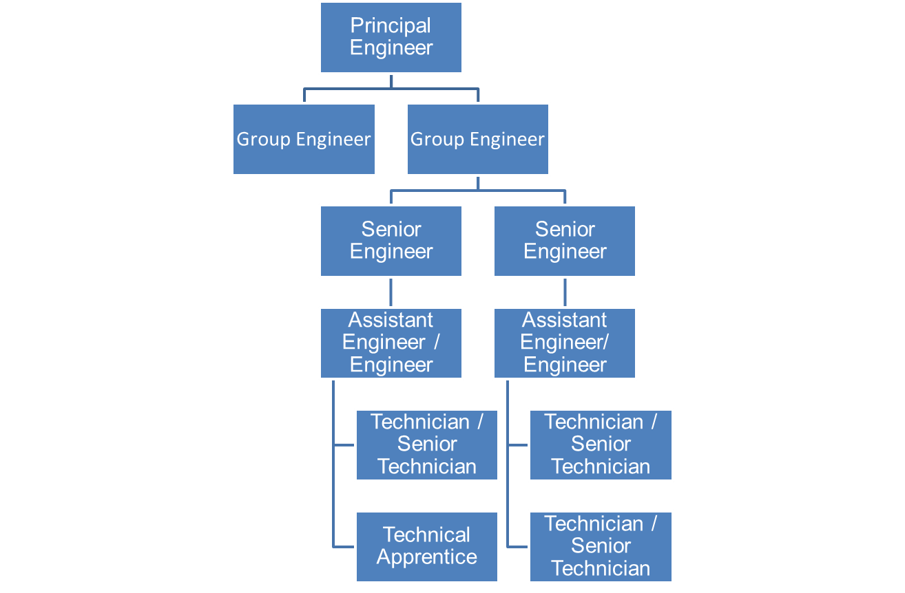

Special Knowledge Requirement: Will be used for shortlisting.

Applicants with disabilities are only required to meet the essential special knowledge requirements shown by a cross in the end column.
 | Essential
Due to the Governments Fluency in English Duty for posts where employees speak directly to members of the public the post holder is required to meet the Advanced threshold level which will be implemented where the post requires a greater level of sensitive interaction with the public,( e.g. in children’s centres) – where the person is able to demonstrate that they can during the interview:  a) Can express themselves fluently and spontaneously , almost effortlessly  b) Only the requirement to explain difficult concepts simply hinders a natural smooth flow of language | X
Carries out the working practices and procedures across the design & maintenance, civil engineering and procurement activities appropriate to the delivery of capital improvement projects. | X
Uses knowledge of Health, Safety and Environmental policies, procedures and regulations including risk in own work area and/or across other areas of work | X
Uses a range of specialist ICT systems across the civil engineering, works programming, project management and procurement area for sharing information. | X
Contributes to the management of a budget, keeping costs within agreed levels of budget allocations using financial systems to control costs, identify and recommend appropriate corrective actions when appropriate. | X
Uses, interprets, analyses and communicates complex information from a variety of sources and able to draft complex, non-standard letters, emails and reports in a logical and accurate manner. | X
Able to involve partner organisations in the problem solving activity by developing strong working relationships, consulting representatives of partner organisations and gaining their input into decision making processes; ensuring close collaboration between stakeholders. | X
Ability to administer a construction contract including instructing contractors, consultants and specialist service providers, controlling quality & financial outputs. | X
Supports relevant partners / managers in the work of their team with day-to-day organisation of workloads and allocation of resources. | X
Proposes and implements viable solutions to civil and highway engineering problems taking independent initiative. | X

Relevant experience requirement: Will be used for shortlisting

The applicant is required to provide evidence of having previously spoken fluently to members of the public in order to meet the advanced threshold level outlined under Special Knowledge above.
Relevant professional qualifications requirement: Will be used for shortlisting

Chartered or Incorporated Engineer and Member of appropriate professional institution (ICE or similar) or equivalent extensive experience in bridge engineering.

Core Employee competencies at manager level to be used at the interview stage.

Carries Out Performance Management – covers the employees capacity to manage
their workload and carry out a number of specific tasks accurately and at a high standard.
Communicates Effectively - covers a range of spoken and written communication skills required as a regular feature of the job. It includes exchanging information/building relationships, giving advice and guidance, counselling, negotiating and persuading and handling private, confidential and sensitive information.
Carries Out Effective Decision Making - covers a range of thinking skills required for taking initiative and independent actions within the scope of the job. It includes planning and organising, self effectiveness and any requirements to quality check work.
Undertakes Structured Problem Solving Activity - covers a range of analytical skills required for gathering, collating and analysing the facts needed to solve problems. It includes creative and critical thinking, developing practical solutions, applying problem solving strategies and managing interpersonal relationships.
Operates with Dignity and Respect - covers treating everyone with respect and dignity, maintains impartiality/fairness with all people, is aware of the barriers people face.

Management Competencies: to be used at the interview stage.

Operates with Strategic Awareness Our managers work with corporate priorities and policies in a joined up way with others, internally and externally. Works democratically, transparently and accountably.
Practices Appropriate Leadership Our managers motivate their staff to exceed expectations through raising their awareness of goals and moving them beyond self interest for the sake of the team or service. They consider serving the District in all that they do.
Delivering Successful Performance Our managers monitor performance of services, teams & individuals against targets & celebrate great performance. They promote the District’s vision & work to achieve Council’s values & agreed outcomes.
Applying Project and Programme Management Our manager’s work to ensure that outcomes and objectives are achieved within desired timescales, make best use of resources and take a positive approach to contingency planning.
Developing High Performing People and Teams Our managers coach individuals and teams to achieve their potential and take responsibility for continuous improvement. They champion the Council’s values and goals.
Working Conditions:

Must be able to perform all duties and tasks with reasonable adjustment, where appropriate, in accordance with the Equality Act 2010 in relation to Disability Provisions.

May be required to undertake work outside normal office hours, including nights, weekends and Bank Holidays and may be required to participate in emergency and winter stand-by arrangements.

Must be able to travel to any location in the District.

Will be required to attend outdoor sites at all times of year.

Progression through the Post Grade will be in accordance with the approved Career Grade. (See Appendix 1: Engineering Career Grade, Responsibilities and Remuneration Package)
Special Conditions:
You will be informed outline if there is a requirement for the post to have recruitment checks
such as DBS, Warner Process.
Compiled by:  R Gelder  Date: March 2013  Reformated: Jan 2018 | Grade Assessment Date:  Job benchmarked against posts below | Post Grade:  PO2 – PO4
Benchmark Job Descriptions
Senior Engineer (Highway Structures) – PO1 to PO4
ENGINEER CAREER GRADE
RESPONSIBILITIES AND REMUNERATION PACKAGE

The responsibilities of an individual at different levels of the Engineer Career Grade (see below) relate to the following requirements at the specified level.

Senior Engineer – PO3

- Provide independent judgement, innovative advice and guidance based on evaluation and analytical skills to produce alternative solutions to a wide range of complex engineering problems, formulate recommendations and solutions and deputise for the Principal Engineer from time to time.

- The programming and delivery of engineering solutions with the minimum of guidance.

- Assist the Principal Engineer and where appropriate lead on the planning and managing of service improvements based on a performance management framework and communicate progress to customers and partners.

Senior Engineer – PO4

- Arrange and chair contractual, progress and liaison meetings to pro-actively deliver allocated schemes.

- Mentor technicians and engineers on technical and procedural matters based on a sound understanding of core engineering principles and knowledge of the values of the Council.

Senior Engineer Posts
Scale | Designation | Qualifications and Experience
PO2 | Senior Engineer | - HNC/D in Civil Engineering (pre-1999 intake) or related discipline OR BSc (Hons) in Civil Engineer (post 1999 intake) OR NVQ Level 6 in Civil Engineering OR other qualification certified by the Engineering Council UK as academic base for Incorporated Engineer status  - Incorporated Engineer status OR Transport Planning Professional Training Review OR ICE Career Appraisal for Member Professional Review  - Band 2 Engineering Competencies demonstrated at minimum ‘Good’ Level
PO3 | Senior Engineer | As PO2 plus:  - NVQ Level 4 in Management or CMS  - Further Progression with Incorporated Engineer Status OR Transport Planning Professional Qualification OR Chartered Membership of the Institute of Logistics and Transport.  - Band 3 Engineering Competencies demonstrated at minimum ‘Good’ Level
PO4 | Senior Engineer | As PO3 plus:  - M.Eng degree (post 1999 intake) in Civil Engineering OR B.Eng(Hons) Degree in Civil Engineer (pre-1999 intake) OR Technical NVQ Level 7 in Civil Engineering OR other qualification certified by the Engineering Council UK as academic base for Chartered Engineer. PLUS NVQ Level 5 in Management  - Chartered Engineer status OR further progression with Transport Planning Professional Qualification OR further progression with Chartered Membership of the Institute of Logistics & Transport.  - Band 3 Engineering Competencies demonstrated at minimum ‘Informed’ level.

