CITY OF BRADFORD METROPOLITAN DISTRICT COUNCIL
NEW 05
JOB PROFILE

DEPARTMENT: Legal and Democratic Services | SERVICE GROUP: Social Care
POST TITLE: Lawyer/Senior Lawyer  (Social Care) (children) | REPORTS TO: Team Leader  (Social Care)
GRADE: PO3/PO6 |  | SAP POSITION NUMBER :

The following information is furnished to help Council staff and those people considering joining the City of Bradford Metropolitan District Council to understand and appreciate the general work content of their post and the role they are to play in the organisation. The following points should be noted:

The employee competencies are the minimum standard of behaviour expected by the Council of all its employees and the management competencies outlined are those relevant for a post operating at this level within our organisation.

Both sets of competencies will be used at interview stage and will not be used for short listing purposes. As a candidate/employee you will be expected to demonstrate your ability meet the special knowledge, experience and qualifications required for the role by providing evidence in the application form for the purpose of shortlisting.

Key Purpose of Post:
To assist the Team Leader and the Deputy Team Leaders in the provision of high quality professional legal services to Children’s Services (as may be delegated through the Bradford Children and Families Trust) primarily in relation to children’s law, safeguarding and procedure concerning children and vulnerable young persons. To provide supervision and support to more junior staff when required.

Main Responsibilities of Post:
The post holder is required to exercise professional judgment and make all day-to-day operational decisions on allocated matters and cases in the context of legal advice and representation to the instructing client and provide assistance given to Council Officers and Members as required. The post holder is not expected to make strategic decisions, as this is the role of the Team Leader, Deputy Team Leader, Head of Legal and Director of Legal and Governance but is expected to contribute to the development of the service provided and to provide supervision and support to more junior staff as the post holder develops within their role.

The post holder is expected to influence and negotiate with contacts both internal and external to the council. Contacts include Officers at Chief Executive level and below, elected members, Courts, Tribunals and regulatory bodies of staff, private practice solicitors and barristers and other professionals involved in the area of work.
The main duties of the post are:

- To act as a case holder, representative and advocate, in providing professional legal services to the Children’s Services (as may be delegated through the Bradford Children and Families Trust) in relation to legal issues relating to children and vulnerable young persons and seek suitable supervision as required. This will include attendance at case/legal planning meetings, advocate meeting, public law outline meetings and the family court. Advice and representation may also be required in respect of the Deprivation of Liberty Court and Court of Protection, where appropriate.

- To give legal advice and guidance to the Children’s Services (as may be delegated through the Bradford Children and Families Trust) and to Committees and Sub-Committees of the Council.

- To act under pressure in the face of competing demands arising from emergency and urgent situations.

- To co-ordinate the work relating to Social Care matters, to ensure that cases are prepared to professional standards and in compliance with relevant legislation, Regulations, Statutory Guidance, Practice Directions and the Public Law Outline and to ensure that Court commitments and deadlines are properly met.

- To undertake such duties as may be allocated by the Team Leader or Deputy Team Leader, to include the preparation of reports, advice and guidance.

- To assist with the duty rota, attendance at the Legal Gateway Panel and any other committees, sub-committees, members, officers and any organisation with which the council has a formal arrangement for the giving of advice.

- To provide professional legal services to the Chief Executive, Human Resources, Environment & Sport, Finance, Public Health, Regeneration & Culture and the West Yorkshire Pension Fund as may be required from time to time.

- To assist other public authorities within the West Yorkshire area on Social Care law matters/cases and in other areas of law as may be required from time to time.

The post holder is responsible for confidential case papers and files.

Structure

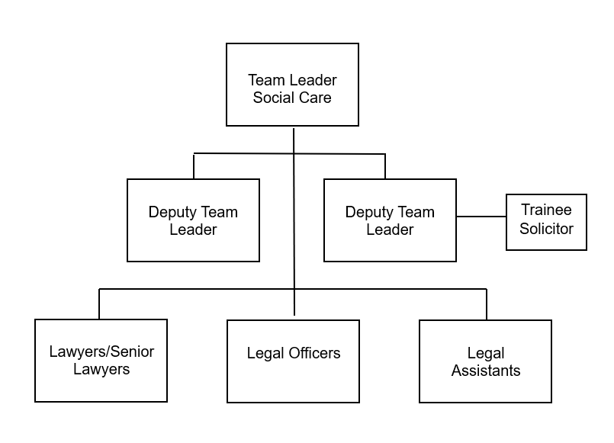

Provides the legal service to the Children’s Services and Adult & Community Services Departments.
Special Knowledge Requirement:
Applicants with disabilities are only required to meet the essential special knowledge requirements shown by a cross in the end column.
 |  |  | Essential
Due to the Governments Fluency in English Duty for posts where employees speak directly to members of the public the post holder is required to meet the Advanced threshold level which will be implemented where the post requires a greater level of sensitive interaction with the public,( e.g. in children’s centres) – where the person is able to demonstrate that they can during the interview:  a) Can express themselves fluently and spontaneously , almost effortlessly  b) Only the requirement to explain difficult concepts simply hinders a natural smooth flow of language  If this applies to the post you are recruiting to do not remove it . |  |  | X
Carries out the working practices, procedures and operations across the specialist area of social care legal work in relation to children and vulnerable adults. |  |  | X
Understands and applies health and safety working practices, including risk in their own area of work. |  |  | X
Uses a wide range of basic computer applications and case management systems including access to the court portal |  |  | X
Knows and understands how to analyse, interpret and present complex information from a variety of sources |  |  | X
Relevant experience requirement:
Experience as a paralegal, legal officer, trainee solicitor, solicitor, barrister or Fellow of the Chartered Institute of Legal Executives the area of law relating to safeguarding, children and/or vulnerable adults.
Relevant professional qualifications requirement:
The post holder will be a solicitor entitled to practice in England and Wales and hold a practising
certificate, a barrister entitled to practice in England and Wales
holding a current practising certificate or a Fellow of the Chartered Institute of
Legal Executives.
Core Employee Competencies
Carries Out Performance Management
Communicates Effectively
Carries Out Effective Decision Making
Undertakes Structured Problem Solving Activity
Operates with Dignity and Respect
Management Competencies
Operates with Strategic Awareness
Practices Appropriate Leadership
Delivering Successful Performance
Applying Project and Programme Management
Developing High Performing People and Teams
Working Conditions:
Must be able to perform all duties and tasks with reasonable adjustment, where appropriate, in accordance with the Equality Act 2010 in relation to disability provisions.

Must be able to work evenings, weekends and Bank Holidays as required by the needs of the service.
Special Conditions:
Management may require that a Disclosure and Barring Check or similar be carried out as part of the recruitment process.
Compiled by:  Ruth Shedlow  Date: 27.02.25 | Grade Assessment Date: | Post Grade:
For HR use only | SAP Input Date | Name of Data Inputter

/tmp/in/input.doc

