Job Profile
Reference Number | bradfordmbc/TP/44952/2330
Role Title | Changing Futures Programme Manager
Grade | Special A
Directorate | Adults Social Care
Department | Public Health
Reports to | Consultant in Public Health

Role Purpose
Bradford City Council have an exciting opportunity to play a pivotal and leading role in delivering our ambitions to respond to Multiple Disadvantage in Bradford and Changing Futures, a strategic programme designed to bring about systems change for adults experiencing multiple disadvantage. The role will require working at a strategic level with partners from across Bradford including other public sector organisations and the VCSE sector.
We are building a new approach to public service delivery. Breaking down the silos between public services, and promoting ways of working around people, place and prevention. You will be vital in developing and delivering innovation and system change for Changing Futures.
Working as part of an established core team and closely with local authorities, the ICB, police, probation, government departments, voluntary and community sector enterprises and a broad range of local partners, you will be responsible for development and alignment of the multiple disadvantage agenda which contributes effective delivery of the Changing Futures programme.

Accountabilities
- To lead on the successful implementation of Changing Futures in Bradford.
- To influence, support and work with senior leaders to drive forward the programme, by embedding and supporting local and regional systems to more effectively respond to adults experiencing multiple disadvantage through clear programme and project planning.
- Take lead responsibility for effective stakeholder management, to build strong partnership working and identify and realise the programme benefits, their linkages to other Council and partner programmes in line with District priorities.
- Responsible for the development and management of effective governance arrangements, performance and monitoring measures and procedures for the relationship with key stakeholder groups including the Ministry of Housing Communities and Local Government, Elected Members, and Senior Officers of the Council and other Partnership Organisations to ensure successful implementation of the Programme
- To ensure project and programme documentation is produced and maintained, including project briefs, project initiation documents, business cases, stakeholder plans, communication plans etc.
- To oversee and direct consultation with service users and providers when required.
- To be fully responsible for managing programme and project risk and issue logs and for reporting to the Changing Futures Steering Group to ensure risks are managed and mitigated.
- To secure and understand the relationship between the delivery of the programme that develops local and regional systems to more effectively respond to adults experiencing multiple disadvantage and their benefits in relation to current local, regional and national policy.
- Establish, lead, manage and monitor a shared and sustainable programme of work around Multiple Disadvantage & Multiple Complex Needs across Bradford.
- To ensure that appropriate performance monitoring systems are in place with regard to schemes in construction and operational phases.
- To professionally represent the Changing Futures Steering Group and the Authority as required at internal and external networking events, conferences and meetings as required.
- To write, draft and contribute (as appropriate) to the preparation and presentation of reports, in a pre-agreed format to the Changing Futures Steering Group and Executive.
- To be responsible for overall programme audit trail, including recording of all decisions for governance purposes and financial accountability.
- To manage external consultants’ and private sector advisors and ensure their compatibility with major project and overall programme plans.
- To work in accordance with Council Financial Regulations and Standing Orders to manage the use of resources and agreements allocated to major projects
- To investigate, share and transfer best practice to improve capacity within the Council and ensure all possible lessons learned and knowledge transfer opportunities are exploited.
- To provide professional advice, guidance and information on all aspects of the above to elected members, officers, partners and citizens as required.
- To ensure that the Council’s policies and strategies reflect the Council’s equality objectives in order to eliminate discrimination, advance equality of opportunity, foster good relations with all

Knowledge / Skills / Experience required
Experience
Significant experience of operating at a senior management level within a large multifunctional public service organisation, and in a service area relevant to the specific post.

Significant experience of facilitating work groups, implementing change and programme and project management.

Knowledge and Skills
- Demonstrate an understanding of the duties and responsibilities that underpin the
- work of the Inclusive Workforce Partnership
- Able to carry out business processes review activities including mapping processes and identifying Improvements
- Able to carry out business analysis, programme management, project management, business process testing, change implementation planning and management, organisation design and implementation and benefits management
- Demonstrate understanding of key government policies and new legislation
- impacting upon the functions, leadership and organisational parameters of
- CBMDC and its partners
- Able to work effectively with colleagues (and other stakeholders including citizens) across the Council and in partner organisations in related strategic support and operational functions including all types of planning, performance management, improvement, research and consultation, strategic finance, HR and Legal, etc., as well as with strategic leaders and elected members, in order to collectively support the achievement of the Council’s purposes and priorities.
- Able to successfully manage projects from initiation through to completion, including the development and introduction of new initiatives
- Able to establish a clear end point with measurable outcomes
- Actively involves others in the planning process
- Identifies risks and establishes appropriate strategies to counter them
- Able to facilitate partnership working to develop and implement strategies that deliver improved outcomes for local citizens

Dimensions of role (direct/ indirect as applicable) eg total number of staff managed/ total budget/ total scope of role
- Matrix Management responsibility for all staff associated directly or indirectly with programme implementation and to manage any staff assigned to the post holder including short term Project Officers, Consultation staff and Analysts from a range of organisations
- Responsible for the discipline, motivation, recruitment, development and training of core staff and secondees including staff from across the organisation and beyond as necessary, including senior consultants and other specialists from outside the organisation
- Access to extremely confidential and sensitive, corporately and commercially sensitive information relating to individuals, public and private institutions, bid information, service areas, strategic and policy development.
- Responsible for the management of significant capital and revenue budgets
To attend and present information, reports and recommendations to the Changing Futures Steering Group, other council committees, CMT and partnership boards as an advisor with or on behalf of the Consultant in Public Health.

Structure Chart (role of direct reports)
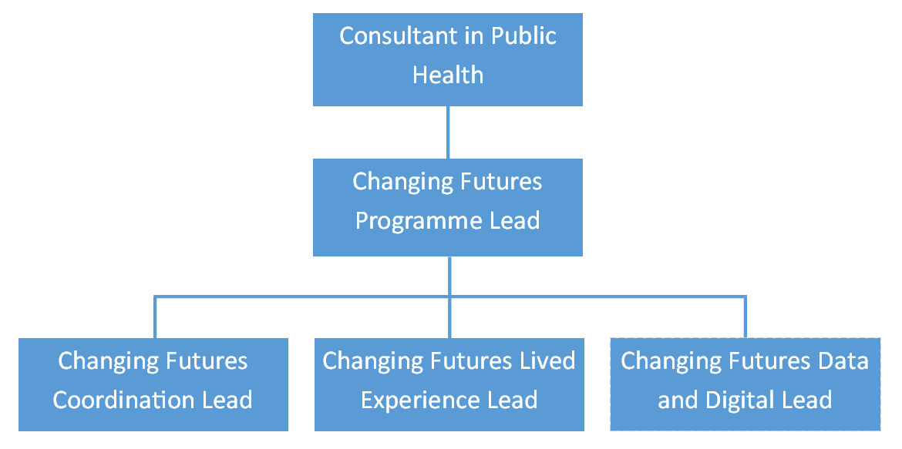

Key benchmarked competencies, traits and motives required to successfully deliver the role (not required for JE. Informs recruitment, succession planning, development and performance management
- Carries Out Performance Management – covers the employees capacity to manage their workload and carry out a number of specific tasks accurately to a high standard.
- Communicates Effectively - covers a range of spoken and written communication skills required as a regular feature of the job. It includes exchanging information/building relationships, giving advice and guidance, counselling, negotiating and persuading and handling private, confidential and sensitive information.
- Carries Out Effective Decision Making - covers a range of thinking skills required for taking initiative and independent actions within the scope of the job. It includes planning and organising, self effectiveness and any requirements to quality check work.
- Undertakes Structured Problem Solving Activity - covers a range of analytical skills required for gathering, collating and analysing the facts needed to solve problems. It includes creative and critical thinking, developing practical solutions, applying problem solving strategies and managing interpersonal relationships.
- Operates with Dignity and Respect - covers treating everyone with respect and dignity, maintains impartiality/fairness with all people, is aware of the barriers people face.
- Operates with Strategic Awareness Our managers work with corporate priorities and policies in a joined up way with others, internally and externally. Works democratically, transparently and accountably.
- Practices Appropriate Leadership Our managers motivate their staff to exceed expectations through raising their awareness of goals and moving them beyond self interest for the sake of the team or service. They consider serving the District in all that they do.
- Delivering Successful Performance Our managers monitor performance of services, teams and individuals against targets & celebrate great performance. They promote the District’s vision & work to achieve Council’s values & agreed outcomes.
- Applying Project and Programme Management Our manager’s work to ensure that outcomes and objectives are achieved within desired timescales, make best use of resources and take a positive approach to contingency planning. Applying Project and Programme Management Our manager’s work to ensure that outcomes and objectives are achieved within desired timescales, make best use of resources and take a positive approach to contingency planning.
- Developing High Performing People and Teams Our managers coach individuals and teams to achieve their potential and take responsibility for continuous improvement. They champion the Council’s values and goals.

