CITY OF BRADFORD METROPOLITAN DISTRICT COUNCIL
JOB PROFILE

DEPARTMENT: Place | SERVICE GROUP: Economy & Development
POST TITLE: International Business Officer (National Services) | REPORTS TO: Senior Manager, Innovate UK Business Growth
GRADE: SO1 |  | SAP POSITION NUMBER : 50199581

The following information is furnished to help Council staff and those people considering joining the City of Bradford Metropolitan District Council to understand and appreciate the general work content of their post and the role they are to play in the organisation. The duties and responsibilities highlighted in this Job Profile are indicative and may vary over time. Post holders are expected to undertake other duties and responsibilities relevant to the nature, level and scope of the post and the grade has been established on this basis.
For posts where employees speak directly to members of the Public the post holder is required to demonstrate their ability to speak fluently in English.

As a candidate you will be expected to demonstrate your ability to meet the special knowledge, experience and qualifications required for the role by providing evidence in the application form for the purpose of shortlisting. Applicants with disabilities are only required to meet the essential special knowledge requirements shown by a cross in the end column of this section.

The employee competencies are the minimum standard of behaviour expected by the Council of all its employees and the management competencies outlined are those relevant for a post operating at this level within our organisation.

Both sets of competencies will be used at interview stage and will not be used for short listing purposes.

Key Purpose of Post:
To help deliver the Innovate UK Business Growth (IUK BG) services at national level, in particular by:

- Answering enquiries received via the national website or enquiry gateway and /or referring to other experts where appropriate;
- Acting as the specific contact point for business queries resulting from the UK’s changing economic and trading relationship with the EU and other countries;
- Answering questions from Network partners outside the UK regarding national legislation, standards or market information.

Main Responsibilities of Post:
- To handle enquiries from UK firms on matters relating to innovation and international
working (for example on relevant national legislation and standards in other countries
covered by the Enterprise Europe Network (EEN), funding opportunities and
appropriate market information), which are received via the National Enquiry Gateway
services (website, e-mail, enquiry line, social media);

- To act as a specific contact point within the UK National Enquiry Gateway (NEG) team
for queries relating to the business impact of the UK’s changing economic and trading
relationship with the EU;

- To refer enquiries of a complex or specialist nature to other members of the IUK BG
team, where appropriate, to ensure that businesses get relevant expert information or
advice;

- To signpost companies to other support services and organisations which may be appropriate to their business, including those offered by Innovate UK, Department for Business & Trade and other local, regional and national business support services;

- To maintain accurate records of all interactions with companies in the customer relationship management system of the IUK BG and to help maintain data integrity within this database;

- To produce any reports and analysis of enquiry trends, business concerns and feedback, as may be required by the Senior Manager or the Monitoring & Performance Team of IUK BG at Innovate UK;

- To be responsible for the security of any company /personal data and to respect and maintain confidentiality as required;

- To answer questions received from Network partners in other countries about UK legislation, policies, standards, market information etc and to record these enquiries in the client management system;

- To help produce national content for the IUK BG website and newsletter, including news items on key developments relating to international collaboration and innovation, as well as success stories of companies assisted;

- To assist in the promotion of the IUK BG and its services in general, for example via attendance at, or organisation of, events and exhibitions;

- To take part in any training or professional development activity which may be identified as appropriate through staff appraisals and to participate actively in any team meetings or training workshops as may be organised at local, regional, national or European level;

- To assist with other aspects of the section’s work, as directed by the Senior Manager or the Economy & Development Service Manager of Bradford Council;

- The post holder may be asked to supervise the Project Support Officer in the absence of the Senior Manager as well as any trainees or placement students from time to time. He / she will work with other members of staff and with consortium partners to deliver a service to businesses and other business support organisations throughout the UK. This will also require liaison with Innovate UK, other members of the EEN throughout Europe and beyond and potentially with the European Commission and its agents, in particular the European Innovation Council and SMEs Executive Agency (EISMEA);

- The postholder will make decisions on the day-to-day running of the national enquiry service, under the guidance of the Senior Manager. This will include decisions on the best approach(es) to be taken to help companies, including the referral to other Network partners or support organisations where appropriate;

- The post holder will have contacts with businesses, the general public, members of IUK BG throughout the UK and abroad, other business support agencies (including Government agencies), Innovate UK, other Council officers (including senior officers), EISMEA, the European Commission and suppliers

Structure:
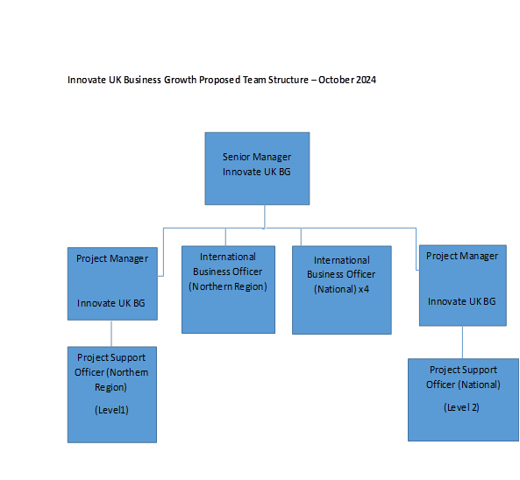
Special Knowledge Requirement: Will be used for shortlisting.

Applicants with disabilities are only required to meet the essential special knowledge requirements shown by a cross in the end column.
 | Essential
Due to the Government’s Fluency in English for posts where employees speak directly to members of the public the postholder is required to meet the Advanced threshold level which will be applied where the postholder requires a greater level of sensitive interaction with the public.  You must be able to demonstrate that you can express yourself fluently and spontaneously (this will also be tested during the interview). | X
Able to establish the needs of the customer using appropriate questioning techniques and listening skills and uses them to implement solutions | X
Able to assimilate and apply complex and detailed information and relay it to customers | X
Knows and understands how to analyse, interpret and present complex information from a variety of sources | X
Able to control and direct interactions with customers to effective resolution in a timely way, promote the organisation and exceed customer expectations | X
Able to establish, develop and maintain relationships with partner organisations/professionals from other disciplines /sectors/ the local community to deliver services to contract specification | X
Able to implement, maintain and manage accurate information retention systems both manual and computerised | X
Uses a range of complex IT packages relating to Innovate UK BG’s area of work, as well as a range of office equipment | X
Able to promote the IUK BG services to external and internal customers and displays commitment to providing a quality service | X
Able to work as part of a team and carry out multiple activities, prioritising effort while maintaining a focus on the customer | X
Able to establish the needs of the customer using appropriate questioning techniques and listening skills and uses them to implement solutions | X

Relevant experience requirement: Will be used for shortlisting

The applicant is required to provide evidence of having previously spoken fluently to members of the public in order to meet the advanced threshold level outlined under Special Knowledge above.
Recent and demonstrable experience of the delivery of information or advisory services to businesses and / or business support organisations
Relevant professional qualifications requirement: Will be used for shortlisting

Has a degree, or equivalent qualification at RQF level 6 ie BTEC advanced professional
award, certificate or diploma level 6, in an appropriate discipline including
business studies, international business studies, languages with business or European
studies.
Or: has demonstrable experience in the delivery of business support and advice to small & medium sized enterprises
Knowledge of other languages would be an advantage

Core Employee competencies at manager level to be used at the interview stage.

Carries Out Performance Management – covers the employees capacity to manage
their workload and carry out a number of specific tasks accurately and at a high standard.
Communicates Effectively - covers a range of spoken and written communication skills required as a regular feature of the job. It includes exchanging information/building relationships, giving advice and guidance, counselling, negotiating and persuading and handling private, confidential and sensitive information.
Carries Out Effective Decision Making - covers a range of thinking skills required for taking initiative and independent actions within the scope of the job. It includes planning and organising, self effectiveness and any requirements to quality check work.
Undertakes Structured Problem Solving Activity - covers a range of analytical skills required for gathering, collating and analysing the facts needed to solve problems. It includes creative and critical thinking, developing practical solutions, applying problem solving strategies and managing interpersonal relationships.
Operates with Dignity and Respect - covers treating everyone with respect and dignity, maintains impartiality/fairness with all people, is aware of the barriers people face.

Management Competencies: to be used at the interview stage.

Operates with Strategic Awareness Our managers work with corporate priorities and policies in a joined up way with others, internally and externally. Works democratically, transparently and accountably.
Practices Appropriate Leadership Our managers motivate their staff to exceed expectations through raising their awareness of goals and moving them beyond self interest for the sake of the team or service. They consider serving the District in all that they do.
Delivering Successful Performance Our managers monitor performance of services, teams & individuals against targets & celebrate great performance. They promote the District’s vision & work to achieve Council’s values & agreed outcomes.
Applying Project and Programme Management Our manager’s work to ensure that outcomes and objectives are achieved within desired timescales, make best use of resources and take a positive approach to contingency planning.
Developing High Performing People and Teams Our managers coach individuals and teams to achieve their potential and take responsibility for continuous improvement. They champion the Council’s values and goals.
Working Conditions:

Must be able to perform all duties and tasks with reasonable adjustment, where appropriate, in accordance with the Equality Act 2010 in relation to Disability Provisions.
Special Conditions:
You will be informed outline if there is a requirement for the post to have recruitment checks
such as DBS, Warner Process.
Compiled by: JL  Date: 27/11/2020 (updated 7/3/23 & 22/3/24 & 18/06/25) | Grade Assessment Date:  04/12/20 by V Leygue | Post Grade:  SO1

