CITY OF BRADFORD METROPOLITAN DISTRICT COUNCIL
JOB PROFILE

DEPARTMENT: Department of Adult Social Care and Health, Public Health | SERVICE GROUP: HDRC
POST TITLE: Business & Projects Support Officer | REPORTS TO: HDRC Programme Manager
GRADE: Band 8 |  | SAP POSITION NUMBER: 50219246

The following information is furnished to help Council staff and those people considering joining the City of Bradford Metropolitan District Council to understand and appreciate the general work content of their post and the role they are to play in the organisation. The duties and responsibilities highlighted in this Job Profile are indicative and may vary over time. Post holders are expected to undertake other duties and responsibilities relevant to the nature, level and scope of the post and the grade has been established on this basis.
For posts where employees speak directly to members of the Public the post holder is required to demonstrate their ability to speak fluently in English.

As a candidate you will be expected to demonstrate your ability to meet the special knowledge, experience and qualifications required for the role by providing evidence in the application form for the purpose of shortlisting. Applicants with disabilities are only required to meet the essential special knowledge requirements shown by a cross in the end column of this section.

The employee competencies are the minimum standard of behaviour expected by the Council of all its employees and the management competencies outlined are those relevant for a post operating at this level within our organisation.

Both sets of competencies will be used at interview stage and will not be used for short listing purposes

Key Purpose of Post:
To take the lead on developing, capturing, managing and presenting information to evidence and monitor HDRC performance and impact across the programme.

- The role will be responsible for delivering a flexible, proficient and constructive administrative and project support function to the HDRC programme.
- To take the lead and support on developing, capturing and managing information systems to evidence and monitor HDRC performance to a wide range of stakeholders
- To support and deliver the HDRC communication strategy and HDRC events

Main Responsibilities of Post:
- To provide effective administration support function across the HDRC team, including, administration duties such as minute taking and project action logs.
- Assistance and supervision in organisation of programme/project administration across the team, including reporting, quality monitoring, and asset inventory maintenance, under guidance of the Programme Manager.
- Develops, maintains, and optimises data collection systems within the HDRC team for effective monitoring and reporting of the HDRC Programme using arrange of applications including Microsoft (excel, forms., power automate).
- Ensures accurate inputting and updating of information on a range of information systems.
- Acts as the IT champion with the HDRC team, trains people to ensure HDRC reporting systems are understood by users and provides day-to-day support on system usage.
- Assist in the organising of HDRC events.
- Support the development and write content for HDRC newsletter and social media.
- Maintain and develop HDRC Share Point and website and ensure content is kept up to date
- Support the Programme Manager in planning, monitoring and reviewing the development of HDRC in-line with the identified priorities, targets and outcomes.
- Develop, adapt and review key performance indicators and reporting for HDRC performance and impact and disseminate to managers and partners.
- Set up and maintain systems for collection and recording of HDRC performance data as directed by the Programme Manager.
- Assist the Programme Manager to monitor expenditure against budgets. Oversee financial processes including invoices and income.
- Undertake any duties commensurate with the general level of responsibility of this post.
- To fully comply with health and safety, equal opportunities and diversity, quality assurance, safeguarding and data protection.

Structure:

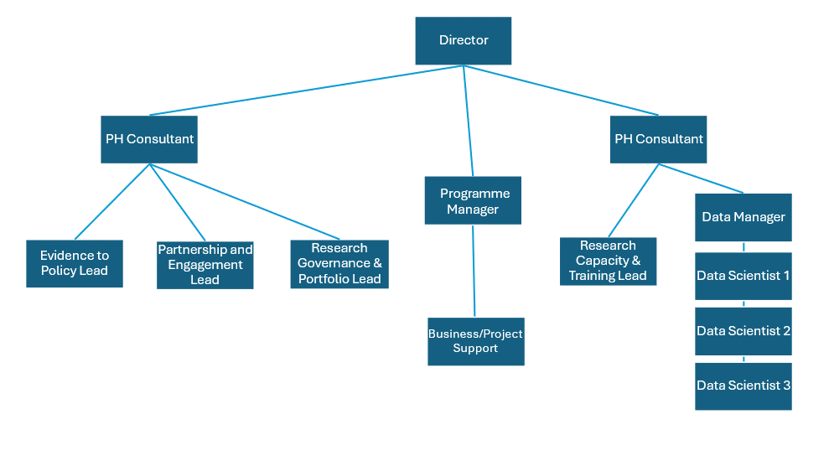

Special Knowledge Requirement: Will be used for shortlisting.
Applicants with disabilities are only required to meet the essential special knowledge requirements shown by a cross in the end column.
 | Essential
Due to the Government’s Fluency in English for posts where employees speak directly to members of the public the postholder is required to meet the Advanced threshold level which will be applied where the postholder requires a greater level of sensitive interaction with the public.  You must be able to demonstrate that you can express yourself fluently and spontaneously (this will also be tested during the interview). | x
Ability to adopt a process of continual improvement and suggest ways of  working more efficiently and effectively to improve service delivery. | x
Knows and understands how to use, interpret, handle and communicate  information | x
Uses knowledge of Health, Safety and Environmental policies, procedures and regulations including risks in own area of work | x
Uses a range of complex IT packages relating to area of work eg Microsoft Office including Excel, Share Point and Share Point 365 . | x
Ability to put together written communication as well as compile reports and other documentation to a high standard with excellent attention to detail. | x
Experience of creating databases and spreadsheets with formulas, queries and reports. | x
Able to communicate sensitively, effectively and appropriately with staff, Managers and other professionals, at all levels, and represent the area of work in a professional and knowledgeable manner. | x
Thinks creatively to help solve multi-faceted problems | x

Relevant experience requirement: Will be used for shortlisting
The applicant is required to provide evidence of having previously spoken fluently to members of the public in order to meet the advanced threshold level outlined under Special Knowledge above.
We are looking for someone with a ‘can-do’ attitude and able to work accurately and efficiently within a busy team environment.
Must have:
- considerable experience of working in a busy office
- the ability to work well under pressure to support a busy team
- to demonstrate good customer service skills
- excellent organisational skills
Demonstrable experience of working in a business administration role.
Relevant professional qualifications requirement: Will be used for shortlisting
5 GCSEs (grade A-C) in English language or equivalent
Minimum of a Level 3 Qualification in appropriate subject e.g. Business Admin is desirable
Core Employee competencies at manager level to be used at the interview stage.
Carries Out Performance Management – covers the employees’ capacity to manage
their workload and carry out a number of specific tasks accurately and at a high standard.
Communicates Effectively - covers a range of spoken and written communication skills required as a regular feature of the job. It includes exchanging information/building relationships, giving advice and guidance, counselling, negotiating and persuading and handling private, confidential and sensitive information.
Carries Out Effective Decision Making - covers a range of thinking skills required for taking initiative and independent actions within the scope of the job. It includes planning and organising, self effectiveness and any requirements to quality check work.
Undertakes Structured Problem-Solving Activity - covers a range of analytical skills required for gathering, collating and analysing the facts needed to solve problems. It includes creative and critical thinking, developing practical solutions, applying problem solving strategies and managing interpersonal relationships.
Operates with Dignity and Respect - covers treating everyone with respect and dignity, maintains impartiality/fairness with all people, is aware of the barriers people face.

Management Competencies: to be used at the interview stage.

Operates with Strategic Awareness Our managers work with corporate priorities and policies in a joined up way with others, internally and externally. Works democratically, transparently and accountably.
Practices Appropriate Leadership Our managers motivate their staff to exceed expectations through raising their awareness of goals and moving them beyond self interest for the sake of the team or service. They consider serving the District in all that they do.
Delivering Successful Performance Our managers monitor performance of services, teams & individuals against targets & celebrate great performance. They promote the district’s vision & work to achieve Council’s values & agreed outcomes.
Applying Project and Programme Management Our manager’s work to ensure that outcomes and objectives are achieved within desired timescales, make best use of resources and take a positive approach to contingency planning.
Developing High Performing People and Teams Our managers coach individuals and teams to achieve their potential and take responsibility for continuous improvement. They champion the Council’s values and goals.
Working Conditions:

Must be able to perform all duties and tasks with reasonable adjustment, where appropriate, in accordance with the Equality Act 2010 in relation to Disability Provisions.
Special Conditions:
Compiled by: Phil Hunter  Updated: Josie Hoy Aug 24  Date: December 2022 | Grade Assessment Date: August 2020 | Post Grade:  Band 8

