CITY OF BRADFORD METROPOLITAN DISTRICT COUNCIL
JOB PROFILE
DEPARTMENT:  Dept of Place | SERVICE GROUP:  HC&PH Licensing Service
POST TITLE:  HC&PH Licensing Service Systems & Operations Support Officer | REPORTS TO:  Licensing Support & Systems Manager
GRADE: SO 2 |  | SAP POSITION NUMBER : 50177031

The following information is furnished to help Council staff and those people considering joining the City of Bradford Metropolitan District Council to understand and appreciate the general work content of their post and the role they are to play in the organisation. The duties and responsibilities highlighted in this Job Profile are indicative and may vary over time. Post holders are expected to undertake other duties and responsibilities relevant to the nature, level and scope of the post and the grade has been established on this basis.

As a candidate you will be expected to demonstrate your ability to meet the special knowledge, experience and qualifications required for the role by providing evidence in the application form for the purpose of short listing. Applicants with disabilities are only required to meet the essential special knowledge requirements shown by a cross in the end column of this section.

The employee competencies are the minimum standard of behaviour expected by the Council of all its employees and the management competencies outlined are those relevant for a post operating at this level within our organisation.

Both sets of competencies will be used at interview stage and will not be used for short listing purposes.

Key Purpose of Post:
- To lead as IT Super User to include technological and cultural change on specific Licensing projects and assist in facilitating electronic service & process re-engineering across the whole of the Licensing Service (including Systems Development Management, Performance, Strategy and Support)

- To provide Operational Support to Management and Officers of the Licensing Service to enable delivery of a cost efficient operation by utilising available resources, policies and procedures effectively

- To develop Licensing Systems solutions to meet the needs of the Licensing Service within a controlled, consistent and co-operative framework to enable data collection, data processing, report production and performance measurement.

Main Responsibilities of Post:
- To explore, identify, initiate and implement creative proposals to continuously improve Licensing Service efficiency and effectiveness.
- Responsible for managing the security and integrity of data across the service to provide accurate and appropriate management information and statistics.
- Maintain and develop Licensing Service applications, connectors and website to their full potential and ensure that they continue to meet current legislation.
- Keeping up to date on technological trends, identifying opportunities to apply them appropriately to the Licensing Service; and either implementing change or making recommendations to senior management as the case may be.
- Monitor the effectiveness of systems, including training requirements and report accordingly; and to organise training courses, demonstrations and presentations as appropriate.
- Exercising analytical skills in complex situations to identify issues and present innovative solutions to senior management.
- Make recommendations on the development of business applications, process improvements and the achievement of Licensing Service objectives.
- Provide first line support and advice for the department’s business applications users and improved work processes and compile and produce training manuals and task profiles.
- Liaise between software suppliers and the Licensing Service as required.
- Ensure effective communication and feedback at appropriate levels including attendance at Cross Divisional and other meetings. Liaise with other sections of the Council with regard to the operation and administration of the computer systems and in relation to matters regarding work processes.
- Exercise professional judgement in the delivery of the Licensing Service and in dealing with Members, the general public, other Council departments, outside bodies, consultants and staff.
- Represent the Licensing Service at external and internal meetings and be an ambassador for the values, goals and objectives of the Licensing Service and the Council.
- Ensure IT systems are compliant with legal and policy requirements and that systems are audited on a regular basis to meet Service and internal Auditing requirements.

Other Operational Duties
- Collate and promulgate information to relevant parties using a variety of communication tools and methods including Web based information, Trade Newsletters, FAQ factsheets, bulletins, attending Trade conferences and delivering presentations
- Assist in the preparation of legal court files, enforcement checks, officer review updates and confidential reports
- Organise diary management and appointments, arranging meetings, taking, writing up and circulating minutes and agendas where required.
- Maintain and co-ordinate confidential customer licensing records

STRUCTURE
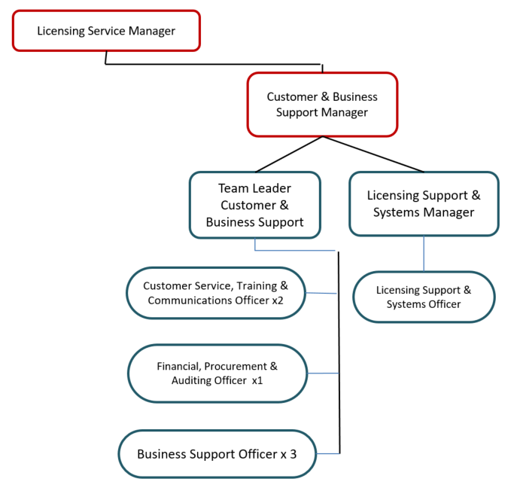

Special Knowledge Requirement. Will be used for short-listing.
 | Essential
Applicants with disabilities are only required to meet the essential special knowledge requirements shown by a cross in the end column.
Due to the Governments Fluency in English Duty for posts where employees speak directly to members of the public the post holder is required to meet the Advanced threshold level which will be implemented where the post requires a greater level of sensitive interaction with the public – where the person is able to demonstrate that they can during the interview:  a) express themselves fluently and spontaneously, almost effortlessly  b) Only the requirement to explain difficult concepts simply hinders a natural smooth flow of language | X
Carries out a variety of working practices, applies complex regulations, rules, procedures and operational processes across a highly technical/specialist area | X
Must be highly computer literate and effectively uses a wide range of advanced computer applications using IT systems/ packages to improve ways of working, observing data protection and information security principles at all times | X
Carries out all work to a very high standard of accuracy, numeracy and literacy | X
Shares specialist knowledge with less experienced colleagues | X
Able to analyse and interpret relevant data / information and communicate complex operational and statistical information | X
Able to look at complex issues and consider the best option/solution to multi-faceted problems | X
Ability to work on own initiative and prioritise and manage own workload | X
Effectively communicates and engages with individuals and groups. | X
Uses knowledge of Health, Safety and Environmental policies, procedures and regulations including risks in own area of work | X

Relevant experience requirement: Will be used for short-listing
Substantial and demonstrable expert knowledge and experience in implementing, user acceptance testing and managing IT business applications, computer systems and databases

Substantial and demonstrable expert knowledge and experience of Microsoft Windows, Office Suite including Power BI, Oracle SQL, and data analysis and migration

Demonstrable experience of working in a very busy and fast paced operational service delivery environment

Whilst not essential, working knowledge of IDOX, IDOX Enterprise, Uniform, SSRS and Tableau would be desirable
Relevant professional qualifications requirement: Will be used for short-listing
Degree or NVQ level 4 in Business Information Technology or Computer Studies

Core Employee competencies to be used at the interview stage.
Carries Out Performance Management
Covers the employee’s capacity to manage their workload and carry out a number of specific tasks accurately and to a high standard.
Communicates Effectively
Covers a range of spoken and written communication skills required as a regular feature of the job. It includes exchanging information/building relationships; giving advice and guidance; counselling, negotiating and persuading and handling private, confidential and sensitive information.
Carries Out Effective Decision Making
Covers a range of thinking skills required for taking initiative and independent actions within the scope of the job. It includes planning and organising, self effectiveness and any requirements to quality check work.
Undertakes Structured Problem Solving Activity
Covers a range of analytical skills required for gathering, collating and analysing the facts needed to solve problems. It includes creative and critical thinking; developing practical solutions; applying problem solving strategies and managing interpersonal relationships.
Operates with Dignity and Respect

Covers promoting equality, treating all people fairly and with dignity and respect, maintains impartiality/fairness with all people, is aware of the barriers people face.
Working Conditions:
Must be able to perform all duties and tasks with reasonable adjustment, where appropriate, in accordance with the Equality Act 2010 in relation to Disability Provisions.
Special Conditions:
The post holder must hold a valid UK driving licence
Compiled by: SW/CS  Date: 28/02/2017  Reviewed ES Aug 24 | Grade Assessment  Date: 9th March 2017 | Post Grade: SO2

