CITY OF BRADFORD METROPOLITAN DISTRICT COUNCIL
JOB PROFILE

DEPARTMENT: Adult Social Care | SERVICE GROUP: People Commissioning and Business Support
POST TITLE: Deputy Service Manager - Financial Support Services (Adult Social Care) | REPORTS TO: Service Manager Financial Supports Services (Adult Social Care)
GRADE: PO5 |  | SAP POSITION NUMBER: 50228442

The following information is furnished to help Council staff and those people considering joining the City of Bradford Metropolitan District Council to understand and appreciate the general work content of their post and the role they are to play in the organisation. The duties and responsibilities highlighted in this Job Profile are indicative and may vary over time. Post holders are expected to undertake other duties and responsibilities relevant to the nature, level and scope of the post and the grade has been established on this basis. For posts where employees speak directly to members of the Public the post holder is required to demonstrate their ability to speak fluently in English.

As a candidate you will be expected to demonstrate your ability to meet the special knowledge, experience and qualifications required for the role by providing evidence in the application form for the purpose of shortlisting. Applicants with disabilities are only required to meet the essential special knowledge requirements shown by a cross in the end column of this section.

The employee competencies are the minimum standard of behaviour expected by the Council of all its employees and the management competencies outlined are those relevant for a post operating at this level within our organisation.

Both sets of competencies will be used at interview stage and will not be used for short listing purposes.

Key Purpose of Post:
- Supporting, enabling and deputising where appropriate for the Service Manager to lead the Adults Financial Support Service. This will involve managing, developing, planning, organising, and delivering a high-quality, effective, and consistent operational financial service that meets the duties set out in the Care Act, Specifically, Care and Support (Charging and Assessment of Resources) Regulations 2014 (“the 2014 Regulations”), made under Part 1 of the Care Act 2014, (including key the preparation and implementation of the Charging Reforms from October 2025), Court of Protection and Office of Public Guardian external inspection process, other legislation. Also, to ensure the Council is compliant with the requirements of the Court of Protection and their external inspection regime via the Office of the Public Guardian.
- To provide strategic leadership and management to the Service Manager and where relevant the wider Adults Financial Support Service and Operational Services to enable the efficient and effective payment of providers and the maximisation of client income through the implementation and management of robust department-wide systems and processes, working with Corporate Services functions to ensure the maximisation of income collection and management of debt and processes for debt recovery, and where they fail consequential write off processes. In addition, feeding into the expected credit liability calculation for the Department of Adult Social Care.
- To ensure that all systems, policies, and processes within the Adults Financial Support Service comply with statutory requirements, including Information Governance in respect of client records, and operate efficiently and effectively, including oversight and learning from complaints and LGO findings relevant to this service.

Main Responsibilities of Post:
- To Support the Service Manager Adults Financial Support Service (FSS) in managing, developing, planning, organising, and delivering the provision of high quality effective, and consistent operational financial service that meets the duties set out in the Care Act and other legislation – covering the following core functions: Managing Contracts, payments and charges for Nursing, Residential, Respite, Direct Payments and Individual Service Funds, while also providing the same service on behalf of Health Services in Bradford, Auditing of Direct Payments on behalf of the Local Authority and the Local ICB’s. Financial Assessments and Welfare Benefits service, Charging and Payments for all Non-Residential services, Managing the personal affairs of service users as Deputy and Appointee & activity related to Public Health Funerals, Preparation and Implementation of the Charging Reforms (date for implementation October 2025) and Day to day operational responsibility for 52.84 FTE staff as delegated by the Service Manager.
- To support the Service Manager in the provision of strategic leadership and management to the Adult Social Care Financial Support Service (FSS) and support to Operational Services in relation to the efficient and effective payment of providers and the maximisation of client income through the implementation and management of robust department-wide systems and processes, including oversight and learning from complaints and LGO findings relevant to this service.
- To provide visible and supportive leadership, which empowers, enables, and develops staff to achieve their potential, through the implementation of an organisational culture that promotes learning, continuous improvement, shared accountability, and drives a high-performing ethos whereby everyone ‘feels they count’ and diversity is valued.
- To directly manage an Administrative Assistant (Projects) and to provide support, coaching and appropriate supervision to the Team Managers as directed by the Service Manager, including day to day operational responsibility for 52.84 FTE staff as delegated by the Service Manager.
- To ensure that all systems, policies, and processes within the Adults Financial Support Service are compliant with statutory requirements, including Information Governance in respect of client records, and operate in an efficient and effective manner. E.g. charging policy. Working with Corporate Services functions to ensure the maximisation of income collection and management of debt and processes for debt recovery, and where they fail consequential write-off processes. In addition, feeding into the expected credit liability calculation for the department of Adult Social Care.
- To ensure that robust systems, activity reporting mechanisms and processes are in place to manage the income, and payments process that are user-friendly and improve the quality of experience for Social Work Staff, Commissioned Care Providers, and individual clients.
- To support the Service Manager to instil a culture of continuous improvement that enables regular reviews of policies, processes, systems and customer contact to ensure that they remain robust and reflect the latest business and statutory requirements and enhance the experience of the people we support.
- To lead in developing, implementing and reviewing a performance management framework that enables a proactive understanding of the progress of key workstreams ensuring timely interventions can be made to ensure that service meets business operational targets, customer quality standards and duties set out in the statutory and regulatory national frameworks (including information governance requirements).
- To support the Service Manager to work with the Digital Innovation Team and Corporate ICT to ensure that where possible best use is made of existing and new technologies to improve the efficiency and effectiveness of systems and processes.
- To support the Service Manager to ensure robust systems are in place that maximise income collection for the benefit of Adult Social Care Services, while also ensuring that support is provided to individual social care clients in maximising their entitlements to available funding through benefits, together with the provision of, and signposting to, services to enable clients to make the most of their disposable income.
- To promote an efficient and effective stewardship of clients’ assets and resources at all times, including acting as a Corporate Appointee/Deputy for clients without capacity as a last resort.
- To build strong and collaborative relationships with internal and external partners and stakeholders (e.g. Partners within the Health and Social Care System), ensuring the views, values, and needs of the organization are fairly and accurately represented in the delivery of integrated services e.g. Management and processing Continuing Health Care contracts and payments.
- To support the Service Manager to actively develop and contribute to partnerships across Social Care and Health to achieve whole systems approaches that are co-produced and meet organisational needs, quality improvement and effective and efficient services.
- To influence and contribute to effective partnership arrangements and networks at local, regional and national levels to bring about change and improvement in the delivery of Adult Social Care services for the benefit of individual clients. Specifically, through working through National Association of Financial Assessment Officers (NAFAO) & Association of Public Authority Deputies (APAD).
- To support the Service Manager to ensure that the service has access to regular and fit-for-purpose training in relation to financial safeguarding, abuse and anti-fraud hat meets the requirements of the Care Act 2014, and that training is regularly reviewed to reflect legislative changes.

Structure:

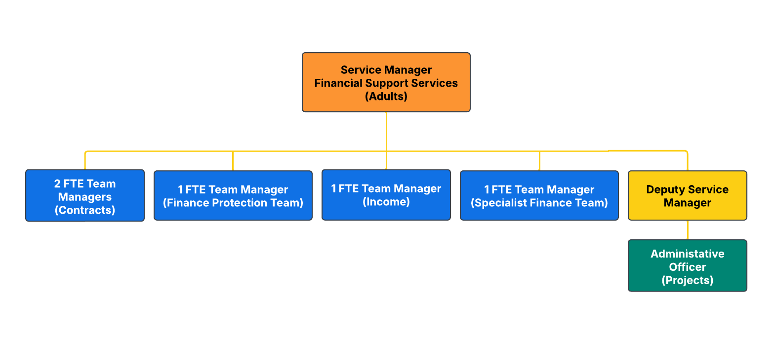

Special Knowledge Requirement: Essential for shortlisting:
Applicants with disabilities are only required to meet the essential special knowledge requirements shown by a cross in the end column
 | Essential
Due to the Government’s Fluency in English for posts where employees speak directly to members of the public the postholder is required to meet the Advanced threshold level which will be applied where the postholder requires a greater level of sensitive interaction with the public.  You must be able to demonstrate that you can express yourself fluently and spontaneously (this will also be tested during the interview). | X
Carries out the working practices, procedures and basic operations across a specialist area or number of specialist areas of Community Care Administration and the Care Act Charging and Support (Charging and Assessment of Resources) Regulations 2014. | X
Uses knowledge, safety and environmental policies, procedures and regulations, including risk in own area and/or other areas of work (inc legislation) | X
Uses a range of specialist ICT systems across own work area and or across other areas of work. | X
Support and deputise (where appropriate) for the Service Manager in the management of a budget, keeping costs within agreed levels for own section/team | X
Uses, interprets, analyses, communicates complex numerical information. | X
Knowledge and demonstrable skills of facilitating business change. | X
Demonstrate knowledge of business architecture and business process | X
Knowledge of business strategic planning and identification of linkages to the digital strategy and IT strategy. | X
Application of business case planning to articulate business requirements | X

Relevant experience requirement: Essential for shortlisting

The applicant is required to provide evidence of having previously spoken fluently to members of the public in order to meet the Advanced threshold level outlined under Special Knowledge above.
Experience in a major service environment providing key support in Community Care Administration.
Leading the work of professional staff developing and implementing corporate strategies and policies.
Extensive experience of instigating and managing change.
Experience of operating in a performance management environment
A record of developing effective partnerships both internally and with external bodies
Leading work in a financial environment and developing effective links with budget holders and senior managers
Working in a political environment.
Experience with managing teams.
Relevant professional qualifications requirement: Essential for shortlisting

Degree, professional qualification in a relevant field experience at management level.
Core Employee competencies at manager level to be used at the interview stage.

Carries Out Performance Management – covers the employee’s capacity to manage
their workload and carry out a number of specific tasks accurately to a high standard.
Communicates Effectively - covers a range of spoken and written communication skills required as a regular feature of the job. It includes exchanging information/building relationships, giving advice and guidance, counselling, negotiating and persuading and handling private, confidential and sensitive information.
Carries Out Effective Decision Making - covers a range of thinking skills required for taking initiative and independent actions within the scope of the job. It includes planning and organising, self effectiveness and any requirements to quality check work.
Undertakes Structured Problem-Solving Activity - covers a range of analytical skills required for gathering, collating and analysing the facts needed to solve problems. It includes creative and critical thinking, developing practical solutions, applying problem solving strategies and managing interpersonal relationships.
Operates with Dignity and Respect - covers treating everyone with respect and dignity, maintains impartiality/fairness with all people, is aware of the barriers people face.

Management Competencies: to be used at the interview stage.

Operates with Strategic Awareness Our managers work with corporate priorities and policies in a joined-up way with others, internally and externally. Works democratically, transparently and accountably.
Practices Appropriate Leadership Our managers motivate their staff to exceed expectations through raising their awareness of goals and moving them beyond self interest for the sake of the team or service. They consider serving the District in all that they do.
Delivering Successful Performance Our managers monitor performance of services, teams & individuals against targets & celebrate great performance. They promote the District’s vision & work to achieve Council’s values & agreed outcomes.
Applying Project and Programme Management Our manager’s work to ensure that outcomes and objectives are achieved within desired timescales, make best use of resources and take a positive approach to contingency planning.
Developing High Performing People and Teams Our managers coach individuals and teams to achieve their potential and take responsibility for continuous improvement. They champion the Council’s values and goals.
Working Conditions:

Must be able to perform all duties and tasks with reasonable adjustment, where appropriate, in accordance with the Equality Act 2010 in relation to Disability Provisions.
Special Conditions:
An Enhanced DBS check is required for this post.
Required to undertake visits to service users.
Compiled by:  B Winter  9.08.2022  Revisited (into new template) 19.08.2023 | Grade Assessment Date: November 2024 | Post Grade: PO5

