CITY OF BRADFORD METROPOLITAN DISTRICT COUNCIL
JOB PROFILE

DEPARTMENT: Children’s Services | SERVICE GROUP: Employment and Skills
POST TITLE: Community Employment Coach/ Employment Adviser / Principal Careers Adviser | REPORTS TO: Employment Operations Manager
GRADE: Band 7 / 8 / SO1 |  | SAP POSITION NUMBER :

The following information is furnished to help Council staff and those people considering joining the City of Bradford Metropolitan District Council to understand and appreciate the general work content of their post and the role they are to play in the organisation. The duties and responsibilities highlighted in this Job Profile are indicative and may vary over time. Post holders are expected to undertake other duties and responsibilities relevant to the nature, level and scope of the post and the grade has been established on this basis.
For posts where employees speak directly to members of the Public the post holder is required to demonstrate their ability to speak fluently in English.

As a candidate you will be expected to demonstrate your ability to meet the special knowledge, experience and qualifications required for the role by providing evidence in the application form for the purpose of shortlisting. Applicants with disabilities are only required to meet the essential special knowledge requirements shown by a cross in the end column of this section.

The employee competencies are the minimum standard of behaviour expected by the Council of all its employees and the management competencies outlined are those relevant for a post operating at this level within our organisation.

Both sets of competencies will be used at interview stage and will not be used for short listing purposes.

Key Purpose of Post:
To be responsible for delivering a range of information, advice and guiandance, work related learning and enterprise activities to ensure clients remain in and progress into employment, education or training. This includes delivering 1:1 impartial information, advice, guidance. You will undertake small/large group work activities including presentations and engage employer’s programmes for clients in or not in education to help clients move into employment or contribute career educational programmes.

The post holder will offer a client-centred service to enable clients to access and achieve suitable employment and career development. To manage and be accountable for a caseload of clients, engaging and maintaining contact with them, referring them to suitable support or training, providing them with individual and group employment skills, work experience and jobsearch support.

Contribute to the development of SkillsHouse as a community-based, all-age single point of access for careers and employment support service for both residents and employers. To undertake employer engagement and community engagement activity for on behalf of the Council and working closely to complement the employer engagement activities undertaken by other partners.

Main Responsibilities of Post:
Duties will include most, or all, of those listed below according to degree of experience and training reached and placement within the technical specialism units of the Service

- To conduct client-focused, impartial, personal career guidance interviews which challenge and support clients to make informed, realistic and adaptable career decisions.
- To provide information, advice and guidance on career, learning and employment choices which is informed by up-to-date local, regional and national labour market information and intelligence.
- Enable clients to identify, access and interpret careers information and intelligence which is relevant to them, including appropriate use of information technology e.g. web-based and social media sources.
- To provide advice about a range of resources, alongside practical support, to deliver programmes of career guidance or employability support programmes, in line with a good understanding of clients’ requirements.
- Support schools/colleges, employers, community partnerships in all aspects of CEIAG delivery including Gatsby benchmarks.
- Work with clients to support their progress into learning, work, or progression in work. This includes tracking September Gurantee / destinations for 16-18 year olds.
- Manage a caseload to meet personal and team targets including, September Guarantee, Activity Survey, NEET target and other performance requirements, through case load support and a range of follow up activity and tracking, including phone and home visits.
- Facilitate/broker high quality provision from appropriate providers that respond to these needs, utilising and maximising existing publicly funded support, where possible and identifying and recording gaps in such support, to feed into new service and commissioning development.
- Work in partnership with colleagues and/or other agencies and partners to provide intensive, sustained, holistic and client centred support.
- Work with other team members and the on-line recruitment resources to match up identified recruitment needs to available labour pool, providing on-going liaison and updates to the employer.
- To refer to and work with specialist services, when required, to support the specific needs of clients e.g. young people with SEND, Children who are Looked After and other vulnerable groups of young people or adults who are at risk of not achieving positive outcomes. Participate in meetings, case conferences and reviews where necessary.
- To generate and maintain client records electronically in order to support personal guidance interviews, including a summary of agreed actions. All recording and follow-up activity to be in line with contract and data processing requirements.
- Build and manage relationships with employers, and the service providers that are in SkillsHouse’ supplier base, and those that are providing services complementary to the SkillsHouse. Making decisions about appropriate support that will meet the needs of the employers that are engaged.
- To deliver the service from where it is best to meet the needs of the individual, including operating from a variety of locations including schools, Jobcentre Plus, training and education providers, community providers and local career hubs. This will include meeting some clients and parents in their home settings.
- To market, promote, and communicate effectively with a range of partners, stakeholders and employers including representing SkillsHouse and the Council at events and in relevant forums and meetings.Meet all standards for quality of service, safeguarding, information and data security, and any other contract requirements
- Undertake any other duties appropriate linked to the role as reasonably requested by Line Manager

Structure:

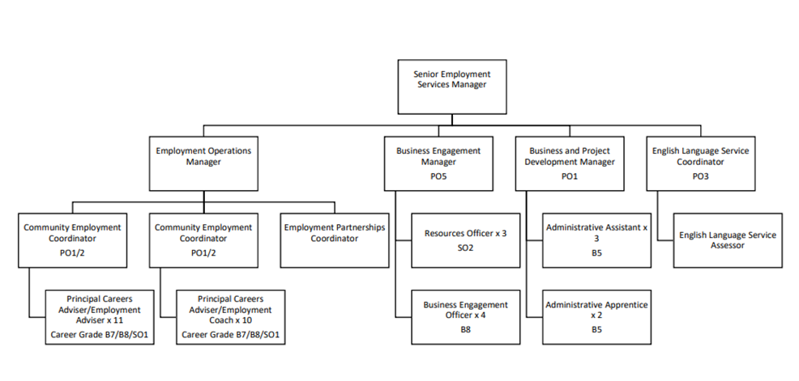

Special Knowledge Requirement: Will be used for shortlisting.

Applicants with disabilities are only required to meet the essential special knowledge requirements shown by a cross in the end column.
 | Essential
Due to the Governments Fluency in English Duty for posts where employees speak directly to members of the public the post holder is required to meet the Advanced threshold level which will be implemented where the post requires a greater level of sensitive interaction with the public,( e.g. in children’s centres) – where the person is able to demonstrate that they can during the interview:  a) Can express themselves fluently and spontaneously , almost effortlessly  b) Only the requirement to explain difficult concepts simply hinders a natural smooth flow of language | x
Carries out the working practices, procedures and basic operations across a specialist area specifically skills and employment service delivery | x
Understands and applies health and safety working practices, including risk in own area of work and or across other areas of work relating to skills and employment service delivery (including safeguarding, etc)
Uses a wide range of basic computer applications including Microsoft Office and client management databases. | X
Knows the costs for products and services within own area of responsibility | X
Knows and understands how to analyse, interpret and present complex information from a variety of sources
Demonstrates a clear understanding of the local job market, an ability to work with employers to provide training and employment solutions and ensure sustained employment is achieved | X
Demonstrates an understanding of the barriers to work and training faced by local residents, working with partners to ensure the needs are met and employability is increased | X
Able to sell services to internal and external customers, maximise business potential and exceed customer expectations | X
Able to develop partnerships and strong working relationships | X
Demonstrates a good understanding of Employment and/or Skills provision and how funding sources can be used to meet needs | X

Relevant experience requirement: Will be used for shortlisting

The applicant is required to provide evidence of having previously spoken fluently to members of the public in order to meet the advanced threshold level outlined under Special Knowledge above.
Good experience of working in a related field providing professional services connecting jobseekers to employment opportunities and engaging with businesses to meet their recruitment needs. Or a minimum of 3 years experience engaging economically inactive
Managing and updating Client Management/ Management Information to collect and provide data to support service delivery and performance management
Relevant professional qualifications requirement: Will be used for shortlisting

NVQ Level 6 in Advice and Guidance or Equivalent eg DIPCG – SO1
NVQ Level 4 in Advice and Guidance. – band 8
NVQ Level 3 in Advice and Guidance. – band 7
A teaching / training qualification e.g. PTLLS, CTLLS would be desirable.
Core Employee competencies at manager level to be used at the interview stage.

Carries Out Performance Management – covers the employees capacity to manage
their workload and carry out a number of specific tasks accurately and at a high standard.
Communicates Effectively - covers a range of spoken and written communication skills required as a regular feature of the job. It includes exchanging information/building relationships, giving advice and guidance, counselling, negotiating and persuading and handling private, confidential and sensitive information.
Carries Out Effective Decision Making - covers a range of thinking skills required for taking initiative and independent actions within the scope of the job. It includes planning and organising, self effectiveness and any requirements to quality check work.
Undertakes Structured Problem Solving Activity - covers a range of analytical skills required for gathering, collating and analysing the facts needed to solve problems. It includes creative and critical thinking, developing practical solutions, applying problem solving strategies and managing interpersonal relationships.
Operates with Dignity and Respect - covers treating everyone with respect and dignity, maintains impartiality/fairness with all people, is aware of the barriers people face.

Management Competencies: to be used at the interview stage.

Operates with Strategic Awareness Our managers work with corporate priorities and policies in a joined up way with others, internally and externally. Works democratically, transparently and accountably.
Practices Appropriate Leadership Our managers motivate their staff to exceed expectations through raising their awareness of goals and moving them beyond self interest for the sake of the team or service. They consider serving the District in all that they do.
Delivering Successful Performance Our managers monitor performance of services, teams & individuals against targets & celebrate great performance. They promote the District’s vision & work to achieve Council’s values & agreed outcomes.
Applying Project and Programme Management Our manager’s work to ensure that outcomes and objectives are achieved within desired timescales, make best use of resources and take a positive approach to contingency planning.
Developing High Performing People and Teams Our managers coach individuals and teams to achieve their potential and take responsibility for continuous improvement. They champion the Council’s values and goals.
Working Conditions:

- Must be able to perform all duties and tasks with reasonable adjustment, where appropriate, in accordance with the Equality Act 2010 in relation to Disability Provisions.
- May be required to undertake work outside normal office hours, including nights, weekends and Bank Holidays.
- Must be able to travel to any location in the District.
- A flexible approach to the work is required, and this may result in staff being temporarily assigned to other teams within the Service thus enabling the work programme to be managed effectively.
Progression through the Post Grade will be in accordance with the approved Career Grade. (See Appendix 1: Careers Adviser Career Grade, Responsibilities and Remuneration Package)

Special Conditions:
You will be informed outline if there is a requirement for the post to have recruitment checks
such as DBS, Warner Process.
Compiled by:  Date: | Grade Assessment Date: | Post Grade:  Band 7 – S01

APPENDIX 1
PRINCIPLE CAREER ADVISER CAREER GRADE
RESPONSIBILITIES AND REMUNERATION PACKAGE

The responsibilities of an individual at different levels of the Adviser Career Grade (see below) relate to the following requirements at the specified level.

Community Employment Coach – Band 7

Employment Adviser – Band 8

Principle Careers Adviser– SO1

Scale | Designation | Qualifications and Experience
Band 7 | Community Employment Coach | - Level 3 in Advice and guidance. Experience to include working on a one-to-one basis to support client into education, learning, employment or other postive outcome
Band 8 | Employment Adviser | As Band 7 plus:  - Level 4 in Advice and Guidacne / LDSS. Good experience of working in a related field providing professional services connecting jobseekers to employment/education opportunities.  - Some schools experience would be advantageous
SO1 | Principal Careers Adviser | As Band 8 plus:  - Level 6 in Information, Advice and Guidance / DipCG/  - In addition a teaching qualification is an advantage  - Good expericne of deliverying high level of CEIAG in a school / college setting providing professional services, connecting jobseekers and schools atenders to education / employment opportunities and engaging with businesses to meet their recruitment needs.

