CITY OF BRADFORD METROPOLITAN DISTRICT COUNCIL
JOB PROFILE

DEPARTMENT: Place | SERVICE GROUP: Markets Service
POST TITLE: Engagement, Events & Programme Officer | REPORTS TO: Promotions & Marketing Officer
GRADE: Band 8 |  | SAP POSITION NUMBER:

The following information is furnished to help Council staff and those people considering joining the City of Bradford Metropolitan District Council to understand and appreciate the general work content of their post and the role they are to play in the organisation. The duties and responsibilities highlighted in this Job Profile are indicative and may vary over time. Post holders are expected to undertake other duties and responsibilities relevant to the nature, level and scope of the post and the grade has been established on this basis.
For posts where employees speak directly to members of the Public the post holder is required to demonstrate their ability to speak fluently in English.

As a candidate you will be expected to demonstrate your ability to meet the special knowledge, experience and qualifications required for the role by providing evidence in the application form for the purpose of shortlisting. Applicants with disabilities are only required to meet the essential special knowledge requirements shown by a cross in the end column of this section.

The employee competencies are the minimum standard of behaviour expected by the Council of all its employees and the management competencies outlined are those relevant for a post operating at this level within our organisation.

Both sets of competencies will be used at interview stage and will not be used for short listing purposes.

Key Purpose of Post:
- To support the creation and delivery of a social media and website content strategy for Darley Street Market and the Markets’ Food Hall. Delivering impactful frequent, regular, year-round multi-platform content campaigns to enhance brand visibility, audience engagement and market attendance.

- To support the creation and delivery of a constant calendar of events, festivals, and activities, covering; cultural and religious, sporting events and other general interest or entertainment events for the Market and the Markets’ Food Hall.

- To source, book, contract and ‘induct’ a range of diverse entertainment or activity for the Food Hall’s ‘Small’ Stage with the aim of programming a full calendar of activities to support the Food Hall across each day, week, month, and season.

Main Responsibilities of Post:
Media Content – Market & Food Hall

- Ensure the Market and Food Hall has a presence on all relevant digital platforms and web content for both Market and Food Hall is always in date, taking down date sensitive content and promotions as they expire.

- Leverage the Markets,’ Food Halls’ and Individual Traders’ potential following by encouraging market traders to repost compelling digital content and thereby encouraging viral marketing.

- Plan, schedule, write, film, edit, publish regular weekly / biweekly multi-platform or linked posts. Coverage should include, but not be limited to; trader introductions, menu specialities, fun with food – competitions – hottest / largest, pre and post event and small stage activity promotions.

- Ensure GDPR compliance with respect to photographic and film content to be posted.

- Build data base of relevant social media influencers, and develop positive working relationships, ensuring their attendance at key events.

Events – Market & Food Hall

6. Support the creation of a full events programme, including but not limed to cultural / religious, , Christmas, Sporting, Music, Film and Dance events. Identity opportunities through income generation through ticketing, sponsorship, and sales.

- Assist in developing a project plan / timeline to deliver each event covering finance, marketing, ticketing, notification of relevant authorities, infrastructure hire, booking of acts / entertainment, additional security and cleaning staff requirements, H&S, sponsorship, event management, event schedules covering mobilisation, live and derig, and debrief.

8. Assist in organising regular event planning meetings covering areas of responsible for each task delivery, update on task development, issues encountered, and remedial actual required to remain on schedule.

9. Assist in coordinating events from mobilisation through derig, acting as the conduit for accurate and current communication between management, internal and external stakeholders, contractors, traders.

10. Prepare a debrief document after each event, with attention to attendance, operational successes / failures and financial performance for the purpose of creating a continuously improving, financially beneficial and engaging event programme cycle.

Programming Food Hall

11. Analysing the markets audience demographic by time of the day, day of the week, and or changes in this demographic across the months in the year or as the market establishes itself in order to create a programme of relevant and compelling events for the small stage / food hall.

- Network, advertise and link with other to develop live music / entertainment data base of entertainers reflective of Bradford and specifically the Food Halls’ diverse audience.

- Assist in maintaining a full calendar of diverse relevant entertainment which drives attendance, increases dwell, increases engagement and ultimately increase F&B trader turnover.

- Review attendance and transactional spends via the Market EPOS system and gather ongoing feedback to refine programming.

15.To actively seek out all sponsorship opportunities for events, entertainment, or potential sponsorship assets, to share with Promotions & Marketing Manager.

Structure:

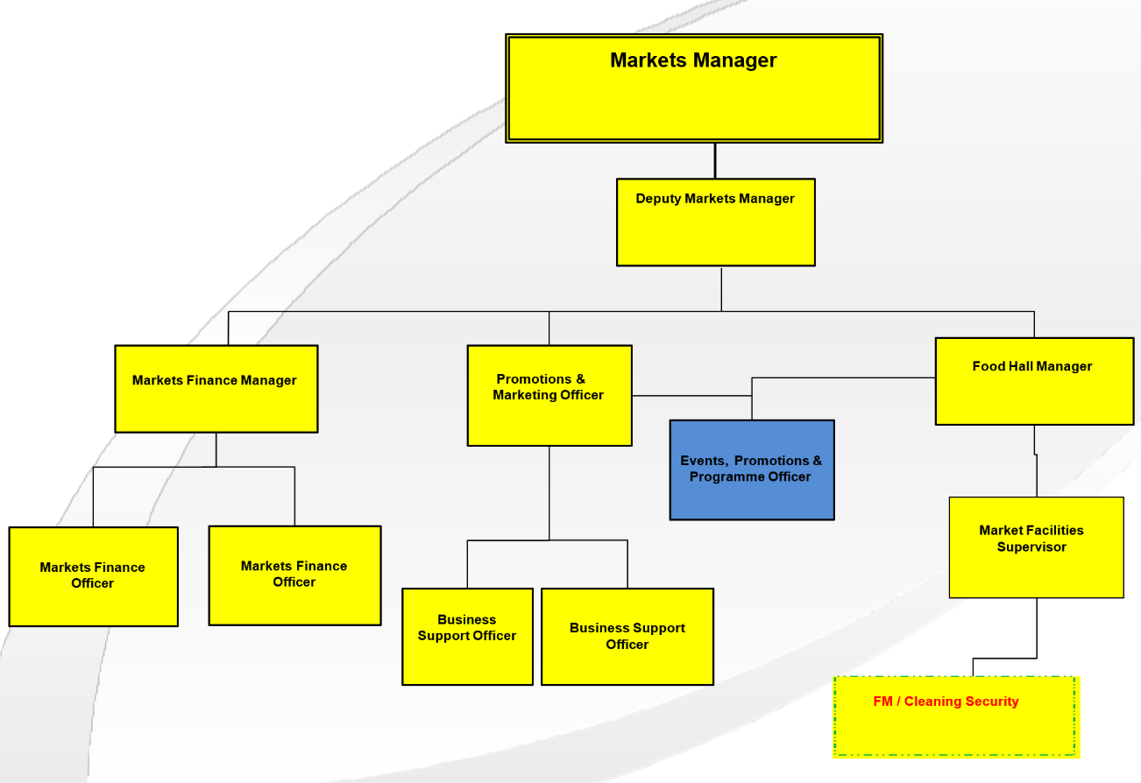
Special Knowledge Requirement: Will be used for shortlisting.

Applicants with disabilities are only required to meet the essential special knowledge requirements shown by a cross in the end column.
 |  |  | Essential
Due to the Government’s Fluency in English for posts where employees speak directly to members of the public the postholder is required to meet the Advanced threshold level which will be applied where the postholder requires a greater level of sensitive interaction with the public.  You must be able to demonstrate that you can express yourself fluently and spontaneously (this will also be tested during the interview). |  |  | X
Carries out the working practices, procedures, and basic operations across a specialist area of budget management and control. |  |  | X
Able to work in a cost-effective way to meet both income and expenditure targets within the department. |  |  | X
The ability to consider wide ranging alternative solutions to problem solving, that may include ‘left field’ solutions. |  |  | X
Must be able to work weekends, evenings and bank holidays as required by the needs of the service for the Catering Team. |  |  | X
Understands and applies health and safety working practices, including risk in own area of work and or across other areas of work events, concerts, and large-scale performances. (incl. legislation). |  |  | X
An understanding of licenses and permits required for outdoor events. |  |  | X
Knows and understands how to analyse, interpret, and present complex information from a variety of sources |  |  | X
Excellent knowledge of social media platforms and social media management |  |  | X
Understanding of the events, leisure, commercial and performing arts industry. |  |  | X
Relevant experience requirement: Will be used for shortlisting.

The applicant is required to provide evidence of having previously spoken fluently to members of the public to meet either the Lower threshold or Advanced threshold level outlined under Special Knowledge above.
Experience of working in events
Experience of working in partnership with a wide range of public and private sector stakeholders
Experience of working with a wide range of artists
Experience of content strategy development
Experience of writing and editing impactful content
Relevant professional qualifications requirement: Will be used for shortlisting

Degree in arts / event management or relevant NVQ LEVEL 4, or practical experience in a marketing and promotional role in either Retail, Leisure, or Food & Beverage.

Current Personal License preferable

Core Employee competencies at manager level to be used at the interview stage.

Carries Out Performance Management – covers the employees’ capacity to manage
their workload and carry out a number of specific tasks accurately and at a high standard.
Communicates Effectively - covers a range of spoken and written communication skills required as a regular feature of the job. It includes exchanging information/building relationships, giving advice and guidance, counselling, negotiating and persuading and handling private, confidential and sensitive information.
Carries Out Effective Decision Making - covers a range of thinking skills required for taking initiative and independent actions within the scope of the job. It includes planning and organising, self-effectiveness and any requirements to quality check work.
Undertakes Structured Problem-Solving Activity - covers a range of analytical skills required for gathering, collating and analysing the facts needed to solve problems. It includes creative and critical thinking, developing practical solutions, applying problem solving strategies and managing interpersonal relationships.
Operates with Dignity and Respect - covers treating everyone with respect and dignity, maintains impartiality/fairness with all people, is aware of the barriers people face.

Management Competencies: to be used at the interview stage.

Operates with Strategic Awareness Our managers work with corporate priorities and policies in a joined-up way with others, internally and externally. Works democratically, transparently and accountably.
Practices Appropriate Leadership Our managers motivate their staff to exceed expectations through raising their awareness of goals and moving them beyond self-interest for the sake of the team or service. They consider serving the District in all that they do.
Delivering Successful Performance Our managers monitor performance of services, teams & individuals against targets & celebrate great performance. They promote the District’s vision & work to achieve Council’s values & agreed outcomes.
Applying Project and Programme Management Our manager’s work to ensure that outcomes and objectives are achieved within desired timescales, make best use of resources and take a positive approach to contingency planning.
Developing High Performing People and Teams Our managers coach individuals and teams to achieve their potential and take responsibility for continuous improvement. They champion the Council’s values and goals.

Working Conditions:

You must be able to work evenings, weekends and bank holidays as required by the
needs of the service.

You must be able to perform all duties and tasks with reasonable adjustment, where appropriate, in accordance with the Equality Act 2010 in relation to Disability Provisions.

Special Conditions:
There is a requirement for the post to have DBS checks.

Compiled by: CW.  Date:22/05/2024 | Grade Assessment Date:  17th October 2024  Ref 00700 | Post Grade: Band 8

