CITY OF BRADFORD METROPOLITAN DISTRICT COUNCIL
JOB PROFILE

DEPARTMENT: Corporate Services | SERVICE GROUP: Legal and Democratic Services
POST TITLE: Legal Assistant | REPORTS TO: Team Leader (Property Commercial Development)
GRADE: Employee Band 5-7 |  | SAP POSITION NUMBER : 11004518

The following information is furnished to help Council staff and those people considering joining the City of Bradford Metropolitan District Council to understand and appreciate the general work content of their post and the role they are to play in the organisation. The duties and responsibilities highlighted in this Job Profile are indicative and may vary over time. Post holders are expected to undertake other duties and responsibilities relevant to the nature, level and scope of the post and the grade has been established on this basis.

As a candidate you will be expected to demonstrate your ability to meet the special knowledge, experience and qualifications required for the role by providing evidence in the application form for the purpose of short listing. Applicants with disabilities are only required to meet the essential special knowledge requirements shown by a cross in the end column of this section.

The employee competencies are the minimum standard of behaviour expected by the Council of all its employees and the management competencies outlined are those relevant for a post operating at this level within our organisation.

Both sets of competencies will be used at interview stage and will not be used for short listing purposes.

Key Purpose of Post:
To assist the Team & Deputy Team Leader Senior Lawyers and Lawyers, Legal Officers in the provision of high quality professional legal services in the area of Development Law for the Council.

Main Responsibilities of Post:
The postholder has authority to make day-to-day operational decisions, with considerable delegation in the day-to-day operation of the work, referring or bringing to the attention of Senior Lawyers and Lawyers complex and/or sensitive issues and cases and contributes to and assists the implementation of new policies/procedures but is not expected to make strategic decisions.

The postholder will have contact with officers within the client departments, private practice solicitors and barristers, Councillors, staff and managers of other agencies such as the Land Registry, Court Service, Planning Inspectorate, Police, Incommunities, and members of the public

The cases can involve multiple parties and can be sensitive, confidential and can be potentially emotionally demanding in nature. The role involves prioritising and meeting planned but also unexpected urgent deadlines.

The role requires the exercise of judgement in managing administrative duties and a case load of routine cases under the overall guidance of the Senior Lawyer.

The postholder will contribute to and assist in the formulation and implementation of new legal policies/procedures

The principal duty is to have responsibility for the conduct of a wide range of town and country planning, highways and local authority licensing matters, including:

Legal Notices, Orders Agreements and Appeals:

- To prepare and issue a Tree Preservation Order (TPO) in accordance with Town and Country Planning Act 1990

- To prepare and issue Section 21 and 16A Orders in accordance with the Road Traffic Regulation Act 1984

- To assist in the processing of completion documents for a highway agreements and planning agreements e.g. Section 106, Agreements 278, Section 38 Agreement

- To assist the Legal Officers/ Lawyers and Senior Lawyers in the processing and preparation of documents and service of statutory notices including notices relating to the obstruction of highways, planning contravention notices and enforcement notices.

- To assist in the preparation of bundles and files for appeal proceedings particularly in connection with public inquiries, section 288 appeals and judicial reviews

- .

Administrative Role

To help provide administrative support to the development team and if necessary the wider Property Commercial and Development Team including opening and closing files, cellar file management and archiving, photocopying, scanning and faxing, preparing routine correspondence and dealing with routine enquiries

Other Duties

To assist in the provision of legal services to the Council and to assist other public authorities within the West Yorkshire area in matters/cases as may be required and which are within the post holder’s capability
Structure:
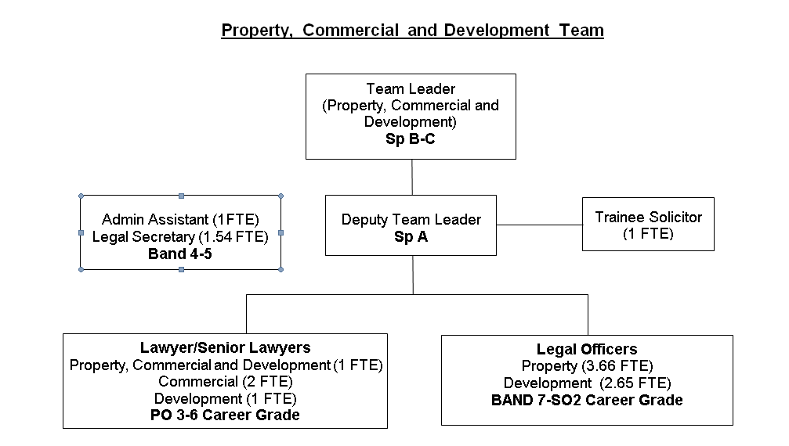

Special Knowledge Requirement. Will be used for shortlisting.
 | Essential
Applicants with disabilities are only required to meet the essential special knowledge requirements shown by a cross in the end column.
Uses knowledge of Health, Safety and Environmental policies, procedures and regulations including risks in own area of  work | x
Uses a range of complex IT packages relating to area of work | x
Ability to adopt a process of continual improvement and suggest ways of  working more efficient and effectively to improve service delivery. | x
Knows and understands how to use, interpret, handle and communicate  information | x
Carries out a variety of working practices, applies complex regulations, rules, procedures and processes relating to legal documentation. | x
Knowledge of the standard layout of legal documentation relating to property commercial and development law (or an ability to learn). | x
Knowledge regarding the use of databases, how they are used in the workplace and how to manipulate information to provide statistical data. | x
Ability to organise a diary, plan and arrange meetings, prepare and distribute paperwork as necessary. | x
Able to demonstrate tact and diplomacy in dealing with enquiries from a wide range of people including Council dignitaries. | x
Understands and is able to operate appropriately the regulations (or demonstrate an ability to learn) the protocols relating to working in a solicitors office | x

Relevant experience requirement: Will be used for shortlisting

Experience of office/clerical work to include experience of working in a solicitors’ office and of carrying out office procedures (or equivalent).
Relevant professional qualifications requirement: Will be used for shortlisting

GCSE in Maths and English grade C or above or equivalent in a relevant subject
e.g. NVQ Level 2, Key Skills Level 2, Skills for Life Level 2, BTEC award, certificate and diploma Level 2.
Typing/Word Processing qualification e.g. RSA/OCR Stage I and Stage II (parts 1 & 2). (or equivalent Typing /word processing skills )
Core Employee competencies to be used at the interview stage.
Carries Out Performance Management
Covers the employee’s capacity to manage their workload and carry out a number of specific tasks accurately and to a high standard.
Communicates Effectively
Covers a range of spoken and written communication skills required as a regular feature of the job. It includes exchanging information/building relationships; giving advice and guidance; counselling, negotiating and persuading and handling private, confidential and sensitive information.
Carries Out Effective Decision Making
Covers a range of thinking skills required for taking initiative and independent actions within the scope of the job. It includes planning and organising, self effectiveness and any requirements to quality check work.
Undertakes Structured Problem Solving Activity
Covers a range of analytical skills required for gathering, collating and analysing the facts needed to solve problems. It includes creative and critical thinking; developing practical solutions; applying problem solving strategies and managing interpersonal relationships.
Operates with Dignity and Respect

Covers promoting equality, treating all people fairly and with dignity and respect, maintains impartiality/fairness with all people, is aware of the barriers people face.
Working Conditions:

Must be able to perform all duties and tasks with reasonable adjustment, where appropriate, in accordance with the Equality Act 2010 in relation to Disability Provisions.
Special Conditions:
You will be informed if there is a requirement for the post to have recruitment checks
such as DBS, Warner Process.
Compiled by:  Date: | Grade Assessment Date: | Post Grade:  Band ……………

