CITY OF BRADFORD METROPOLITAN DISTRICT COUNCIL
JOB PROFILE

DEPARTMENT: Human Resources | SERVICE GROUP: Workforce Learning Development Team
POST TITLE: Workforce Learning & Develoment Co-ordinator | REPORTS TO: Lead Workforce Development Officer/Lead Learning & Development Officer
GRADE: SO2 |  | SAP POSITION NUMBER :

The following information is furnished to help Council staff and those people considering joining the City of Bradford Metropolitan District Council to understand and appreciate the general work content of their post and the role they are to play in the organisation. The duties and responsibilities highlighted in this Job Profile are indicative and may vary over time. Post holders are expected to undertake other duties and responsibilities relevant to the nature, level and scope of the post and the grade has been established on this basis.
For posts where employees speak directly to members of the Public the post holder is required to demonstrate their ability to speak fluently in English.

As a candidate you will be expected to demonstrate your ability to meet the special knowledge, experience and qualifications required for the role by providing evidence in the application form for the purpose of shortlisting. Applicants with disabilities are only required to meet the essential special knowledge requirements shown by a cross in the end column of this section.

The employee competencies are the minimum standard of behaviour expected by the Council of all its employees and the management competencies outlined are those relevant for a post operating at this level within our organisation.

Both sets of competencies will be used at interview stage and will not be used for short listing purposes.

Key Purpose of Post:
To support the Workforce Development Team in the development, delivery and evaluation of a high-quality learning and development offer for Council staff, ensuring it meets the needs set out in Strategic Workforce Plans and aligns with the People Strategy and the Council Plan

Main Responsibilities of Post:
- Support the Workforce Development Officers and the Learning and Development Officers to ensure the learning and development programme meets our mandatory, statutory and regulatory requirements for the Council workforce. Provide support to ensure that the outcomes of the learning provision are consistent with the needs identified in the Department Workforce Plans and the Council Priority Outcomes.
- To assist with the development and maintenance of a workforce development calendar; ensuring that outcomes are aligned with the needs set out in Department Workforce Plans and the Council priorities.
- To assist with identifying and supporting engagement with staff across departments and support the planning, design and delivery of staff engagement sessions.
- Establish good working relationships with the internal communication team to ensure an effective communication plan for the workforce development service is maintained.
- To assist with the planning, co-ordination, development to deliver training and development opportunities using a range of methods and media that reflects the needs of the individual learners and the needs of the service area. To research, develop, promote and embed new ways of delivering learning and design and support e-learning courses when required when reflecting best practice.
- To assist with the council’s apprenticeship programme, graduate scheme, and staff engagement programmes ensuring that our offer is comprehensive, identifying opportunities to work with district partners on the development and provision of programmes which links into the talent pipeline and succession planning.
- Use and SAP/Financial systems to process and raise invoices in line with policies and procedures in the procuring of services. Ensure activities are of high quality and reflect value for money, adhering to commissioning and procurement regulations as necessary.
- To support and co-ordinate workforce activities; Induction, Service Excellence Awards, learning management system, performance reviews, staff surveys, member development, leadership and management development programmes.
- To provide management information, collate and present data relating to workforce Learning and Development compliance and performance.
- To provide first and second line support to internal and external customers with enquiries relating to workforce learning and development.
- Provide a professional and competitive service provision that adds value and is in accordance with Council’s policies, values and vision.
- Comply with regulations, legislation, and best practice in relation to HR services, tenders/procurement, learning and development, advice, and other statutory reporting obligations.
- Undertake any other duties as required by the Workforce Development Service.

Structure
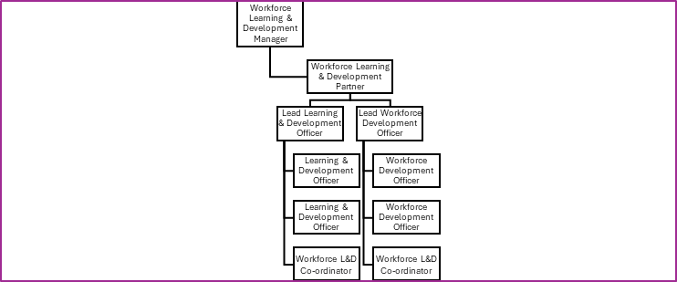

Special Knowledge Requirement. Will be used for shortlisting.
 |  |  | Essential
Applicants with disabilities are only required to meet the essential special knowledge requirements shown by a cross in the end column.
Due to the Governments Fluency in English Duty for posts where employees speak directly to members of the public the postholder is required to meet the Lower threshold level.  You should be able to demonstrate that you can use a wide range of simple words and a standard English sentence structure to express and maintain a flowing conversation even though you pause to think of the correct words with the ability to express and make yourself understood (this will also be tested during the interview). |  |  | X
Ability to follow plans, prioritise and organise tasks from different sources while maintaining a high standard of quality and working under time constraints.
Experience of working effectively in a team, supporting the development of people/services and assisting with the co-ordination of a range of resources connected with service area(s). |  |  | X
Ability to embrace innovation and improvements in the delivery of services to improve standards and cost effectiveness and implement best practice.
Ability to interpret and present data and insights to plan, monitor and report on workloads and respond to customers |  |  | X
Ability to work with HR staff to deliver service and organisational objectives and build effective team relationships and to assist others in developing and achieving their personal, professional, and organisational goals. |  |  | X
Ability to adapt to changing priorities, flexible between demanding sustained work or work as a situation dictates and deliver a quality, people centric service at pace. |  |  | X
Proven track record of ability to communicate, influence and advise stakeholders on workforce development. With specific emphasis on understanding of key trends and needs, e.g., culture, equality, diversity and inclusion, leadership and management, and the use of Workforce data to provide insight and intelligence. |  |  | X
Able to verbally and in written format create and present thoughts and ideas and demonstrate this using a high level of presentation and delivery skills. |  |  | X
Able to use, interpret, analyse, numerical and financial data to monitor and report and communicate it effectively. |  |  | X
Relevant experience requirement: Will be used for shortlisting

Ability to develop positive relationships across all levels of the Council and dealing with people from a variety of different specialisms.
Able to communicate in verbal and written format create and present thoughts and ideas and demonstrate this using a high level of presentation techniques.
Experience of using a wide range of computer applications and being able to analyse statistics and data.
Ability to listen and respond to feedback and present the same message in a variety of different ways to suit multiple audiences.

Relevant professional qualifications requirement: Will be used for shortlisting

Level 3 in a relevant subject or demonstrable experience of working at this level.
Core Employee competencies to be used at the interview stage.
Carries Out Performance Management
Covers the employee’s capacity to manage their workload and carry out a number of specific tasks accurately and to a high standard.
Communicates Effectively
Covers a range of spoken and written communication skills required as a regular feature of the job. It includes exchanging information/building relationships; giving advice and guidance; counselling, negotiating and persuading and handling private, confidential and sensitive information.
Carries Out Effective Decision Making
Covers a range of thinking skills required for taking initiative and independent actions within the scope of the job. It includes planning and organising, self effectiveness and any requirements to quality check work.
Undertakes Structured Problem Solving Activity
Covers a range of analytical skills required for gathering, collating and analysing the facts needed to solve problems. It includes creative and critical thinking; developing practical solutions; applying problem solving strategies and managing interpersonal relationships.
Operates with Dignity and Respect

Covers promoting equality, treating all people fairly and with dignity and respect, maintains impartiality/fairness with all people, is aware of the barriers people face.
Working Conditions:

Must be able to perform all duties and tasks with reasonable adjustment, where appropriate, in accordance with the Equality Act 2010 in relation to Disability Provisions.

Occasionally will need to be able to work evenings, weekends and bank holidays as required by the needs of the service.

Special Conditions:
Compiled by: Elaine Mallinson  Date: 03/07/2024 | Grade Assessment Date:05/09/2024 | Post Grade: SO2

