
City of Bradford Metropolitan District Council Job Profile
Reference Number
Role Title | Casual Swimming Coach
Directorate | Place
Service Area | Sport and Cuture
Reports to | Senior Swim Coach

Role Purpose (maximum of 3 points, with no sub bullet points)
- To support the Senior Coach/Development coach in delivering structured, safe and high‑quality training sessions that promote effective skill development for all swimmers.
- To provide supervised technical guidance, feedback and motivation to swimmers in line with programme standards and within the scope of qualification.
- To contribute to the smooth and professional operation of the coaching programme by assisting with safety, administration, communication and adherence to safeguarding and organisational procedures.

Duties and Responsibilities (maximum of 15 points, with no sub bullet points)
- Assist the Senior Coach & Development Coach in the delivery of structured training sessions in accordance with agreed session plans and programme standards.

- Provide lane supervision to groups of swimmers to ensure safe and effective skill progression under the guidance of the Senior Coach/Development Coach

- Deliver technical feedback on stroke technique, starts, turns and fundamental skills within the scope of own qualification and as directed by senior coaching staff.

- Support the setup and removal of poolside equipment to ensure sessions run efficiently and safely.

- Maintain vigilant supervision of all swimmers to uphold a safe environment and ensure compliance with pool safety procedures.

- Record attendance and assist with basic session‑related administration where requested by the Senior Coach.

- Report swimmer progress, concerns or welfare issues promptly to the Senior Coach or appropriate senior staff.

- Encourage and motivate swimmers through appropriate verbal support, positive reinforcement and consistent coaching behaviours.

- Assist with assessments, swim camps, trials and progression evaluations when required.

- Adhere to all safeguarding, welfare and Health & Safety policies and procedures at all times.

- Follow coaching guidance and instructions from Senior and Development Coaches to ensure consistency across the programme.

- Communicate professionally with swimmers, parents, colleagues and partner organisations as appropriate.

- Support delivery of warm‑ups, cool‑downs and basic land‑based activation exercises within qualification limits.

- Provide flexible support during sessions and assist with cover for lanes or groups when operational needs require

- Demonstrate correct technique or skills as appropriate and within the boundaries of training and qualifications following the LTAD process

Dimensions of role (direct or indirect as applicable) e.g. total number of staff managed, total budget, total scope of role
Dimensions of Role
The postholder contributes to the safe and effective delivery of the swimming coaching programme, providing direct lane supervision and technical support to groups of swimmers under the direction of Senior or Development Coach.

The role involves responsibility for maintaining a safe training environment through supervision, adherence to Health & Safety procedures and supporting safeguarding practices.

The postholder has no direct line‑management responsibilities but plays an important front‑line role in supporting swimmer development and ensuring high‑quality session delivery.

Total Scope of Role
Supports the delivery of sessions for swimmers across a range of ages and abilities, contributing to the consistent operation of the aquatic programme.

Interacts regularly with swimmers, parents, colleagues and partner organisations to maintain strong communication and service standards.

Provides flexible coaching support as required, including covering lanes or groups to meet operational needs, ensuring programme continuity and quality.

Structure Chart (showing direct reports)
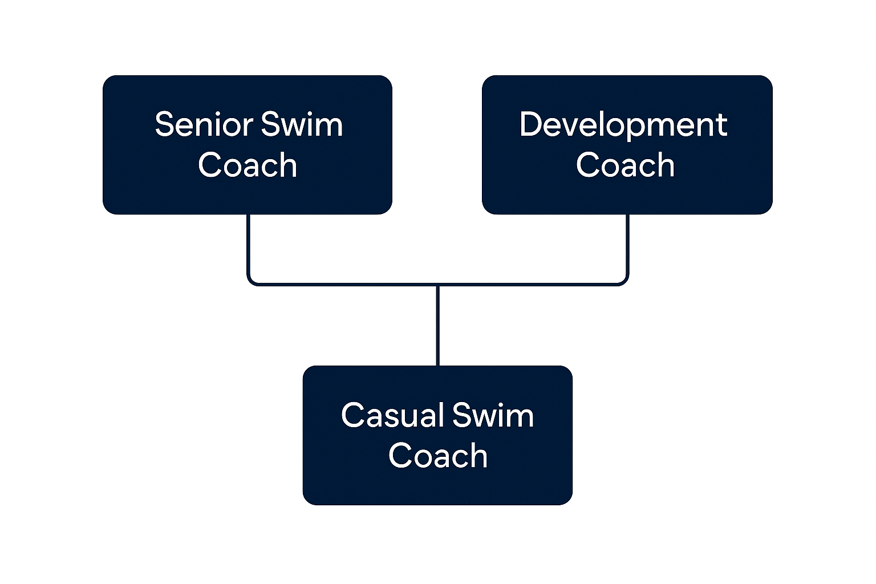

Person Specification
Knowledge / Skills / Experience required
The applicant is required to provide evidence of having previously spoken fluently to members of the public in order to meet either the Lower threshold or Advanced threshold level outlined under Special Knowledge above.
Evidence of previously speaking fluently to members of the public to meet the required fluency‑in‑English threshold.
Extensive / demonstrable experience of coaching swimmers.
Experience in creating and developing swimming development projects at an authority or programme level.
Experience of community consultation and working with local swimming club organisations
Experience of working to deadlines in an operational or coaching environment.

Key benchmarked competencies, traits and motives required to successfully deliver the role These will support recruitment, succession planning, development and performance management |  | Essential
Health and Safety | Uses knowledge of Health, Safety policies, procedures and regulations including risks in own area of work | x
IT Packages | Uses a range of complex IT packages relating to area of work
Service Improvement | Ability to adopt a process of continual improvement and suggest ways of working more efficient and effectively to improve service delivery | x
Continued professional Improvement | Carries out a variety of working practices, applies complex regulations, rules, procedures and processes across a technical /specialist area
Communication | Knows and understands how to use, interpret, handle and communicate, often complex and detailed information, and relay it to service users/stakeholders in writing and/or over the telephone / face to face. | x
Numeracy & Literacy | Demonstrates a high level of numeracy, literacy and accuracy across a range of activities | x
Relevant Professional Qualification | NVQ level 3 or relevant experience working with aquatic community based organisations  ASA/SEQ Level 2 Swim Coaching qualification (minimum)or equivalent  A current NPLQ/NRASTC lifesaving qualification is desireable | x
Carries out performance management | Covers the employees’ capacity to manage their workload and carry out a number of specific tasks accurately and to a high standard. | x
Communicates Effectively | Covers a range of spoken and written communication skills required as a regular feature of the job. This includes exchanging information/building relationships, giving advice and guidance, counselling, negotiating and persuading and handling private, confidential and sensitive information. | x
Carries Out Effective Decision Making | Covers a range of thinking skills required for taking initiative and independent actions within the scope of the job. This includes planning and organising, self-effectiveness and any requirements to quality check work. | X
Undertakes Structured Problem-Solving Activity | Covers a full range of analytical skills required for gathering, collating and analysing the facts needed to solve problems. This includes creative and critical thinking, developing practical solutions, applying problem solving strategies and managing interpersonal relationships. | x
Operates with Dignity and Respect | Covers treating everyone with respect and dignity, maintains impartiality/fairness with all people, is aware of the barriers people face. | x
Practices Appropriate Leadership | Our managers motivate their staff to exceed expectations through raising their awareness of goals and moving them beyond self-interest for the sake of the team or service. They consider serving the District in all that they do.
Operates with Strategic Awareness | Our managers work with corporate priorities and policies in a joined up way with others, internally and externally. Works democratically, transparently and accountably.
Delivering Successful Performance | Our managers monitor performance of services, teams & individuals against targets & celebrate great performance. They promote the District’s vision & work to achieve Council’s values & agreed outcomes.
Applying Project and Programme Management | Our manager’s work to ensure that outcomes and objectives are achieved within desired timescales, make best use of resources and take a positive approach to contingency planning
Developing High Performing People and Teams | Our managers coach individuals and teams to achieve their potential and take responsibility for continuous improvement. They champion the Council’s values and goals.

Applicants with disabilities are only required to meet the essential special knowledge requirements (clearly marked)
Due to the Governments Fluency in English Duty for posts where employees speak directly to members of the public the postholder is required to meet the Lower threshold level.
You should be able to demonstrate that you can use a wide range of simple words and a standard English sentence structure to express and maintain a flowing conversation even though you pause to think of the correct words with the ability to express and make yourself understood (this will also be tested during the interview).

Completed by: | Lynda Devanny | Date: | 06.05.26
Quality checked: |  | Date:

